Makayla Marr
TEK NOTE REVIEW: 06-10A CONCRETE MASONRY RADIANT HEATING/COOLING SYSTEMS
Updated 2006

INTRODUCTION
There are many advantages to using radiant heat. Radiant heat is preferred due to its comfort, quiet operation, and cleanliness. In residential and commercial applications, radiant floors and wall systems have been successfully integrated with concrete masonry due to its ability to heat up and cool down slowly. This improves comfort within the building by moderating temperature swings.

GENERAL DESIGN GUIDANCE
This TEK note gives suggestions and guidelines of how to incorporate these systems in design.
- Thermal mass of concrete masonry should be directly exposed to interior air to function as designed.
- The use of air core floors or walls can be advantageous in uses involving solar heat collection or with conventional heating and cooling systems.
- To obtain maximum heat transfer within air core walls, the placement of concrete masonry units should be placed with the wide end of the taper upstream.
- In reinforced concrete masonry, ungrouted cores can be used for air flow.
- In humid weather, the masonry acts as a desiccant.
- To prevent condensation within the walls or floor, thermal simulation should be performed. This is especially important when outdoor air is used for night cooling.

AIR CORE WALLS
Figure 1 shoes a properly insulated wall that may be used for air core systems. This section provides greater detail in design guidelines and recommendations to provide the most efficient system. Figure 2 shows an example of an Off-peak Thermal Mass (OPTM) wall system which is a modified system where air cores are not sealed. In this case, air distribution occurs between a space in the masonry and the interior gypsum wallboard.
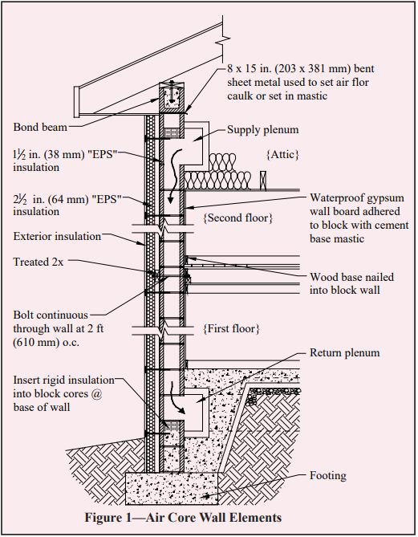
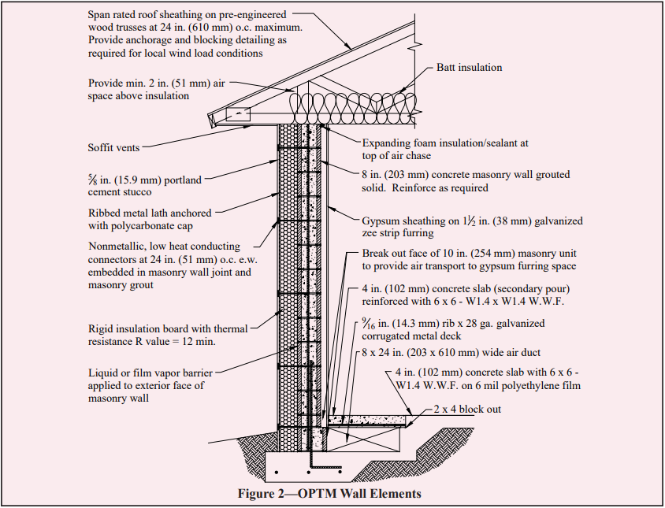

AIR CORE FLOORS
Air core floors are less complex than air core walls therefore more economical. Air core floors are constructed on grade and topped with a concrete finish. Perimeter insulation is a primary factor affecting the performance of air core floors. Specific insulation levels are recommended to prevent excess heat loss. Different climates affect how much insulation is required for heat loss. The use of vapor retarders and caulking and sealing of ducts and plenums can minimize air leaks. Figure 3 shows typical air core floor elements.
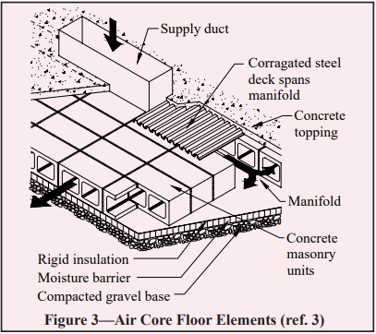

AIR FLOW
Different floor heights serving an air core system require differing forced air flow. The taller the ceiling, the greater forced air required. Air flow rates are determined by the path length of heat exchanged in the system. This TEK note identifies specific air flow rates for associated path lengths.
Different air flow circumstances require different methods to follow in order to achieve regulate air flow. Examples of different situations are detailed in this TEK. For cooling spaces with ventilation, air flow required for this operation is determined using the following relationship. For more specific use, refer to the TEK note for a detailed description.
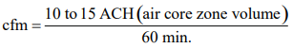

CONTROLS
Sensors are necessary to implement during construction. Sensors can be inaccurate if placed by drilling and insertion after construction. Initial differential controllers for heating should be set on the sensor as follows. Differing circumstances have different recommendations provided in this TEK.
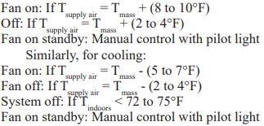
Figure 4 shows a detailed drawing of fan control methods used with air core systems for heating modes. Figure 5 shows a detailed drawing of fan control methods used with air core systems for night ventilation.
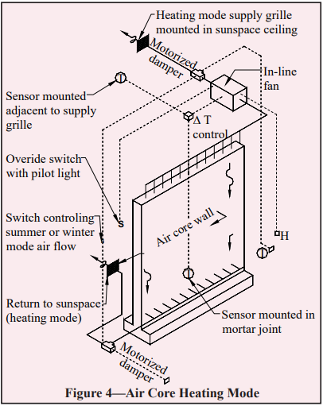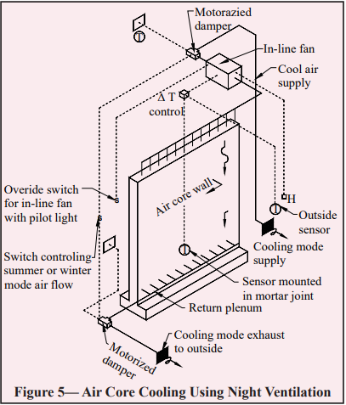

THERMAL STORAGE CAPACITY
Diurnal heat capacity (dhc) is a simple and accurate method for properly sizing distributed thermal mass. DHC is helpful in determining the useful daily energy flux to and from a mass storage system. Optimal temperature swings for any structure can be achieved using this method. References attached to the TEK provide greater detail into the proper sizing and distribution of thermal mass in passive solar application.

