Makayla Marr
TEK NOTE REVIEW: 06 – 05A – Passive Solar Design
Updated 2006

INTRODUCTION
Passive solar design aims to produce a comfortable environment that involves less reliance on mechanical heating and cooling by utilizing the building’s basic elements such as walls, windows, and floors. Implementing passive solar systems can reduce energy costs up to 30-50%.
Concrete masonry is important in passive solar systems as it provides thermal mass to absorb and slowly release solar heat. This allows the building to be comfortable as the sufficient thermal mass provided by the concrete masonry doesn’t allow the building to overheat.

PASSIVE SOLAR IN BUILDING CODES AND LEED
Renewable energy sources are typically not included in energy code criteria meaning that any design will usually comply with the code even if significant elements of design are neglected. Code details total building performance as it compares to costs. Additionally, renewable energy sections apply only to renewably energy systems that generate power.

ELEMENTS OF A PASSIVE SOLAR DESIGN
Elements in a passive solar building are carefully chosen, sized, and located to work together to provide comfort. Function of components including thermal mass, glazing, shading, and ventilation are detailed below to describe the importance in design.
THERMAL MASS
Thermal mass in passive solar design provides three functions: it quickly absorbs solar heat to help avoid overheating, stores solar heat, and slowly releases heat to provide warmth after the sun has set. Concrete masonry walls and concrete paver floors are desired for this use as they serve as efficient thermal storage mediums. These mediums have the ability to maintain comfortable indoor temperatures.
GLAZING
Glazing allows solar heat and light into the building. These spaces are specifically chosen as different heat gain, cooling load avoidance, and daylight needs vary from building to building.
SHADING
Shading helps prevent solar gain in the summer. A variety of options are available based on client preference.
VENTILATION
Venting can rid the building of heat when the thermal mass is saturated as well as provide cool outdoor air to the building when the outside air is cooler than the building interior. Natural ventilation or a thermostatic control exhaust fan can accomplish ventilation need.
TYPES OF PASSIVE SOLAR DESIGNS
Passive solar designs are classified as either a direct gain system, indirect gain system, or an isolated gain system. Classification of system depends on where solar heat is collected relative to where it is used.
DIRECT GAIN SYSTEMS
In a direct gain system, only windows and mass are required making it the simplest to install. In a direct gain space, solar energy penetrates directly into the space where it is stored and then used.
INDIRECT GAIN
In an indirect gain system, a thermal storage material is used between glazing and the space where heat is collected, stored and then distributed. Shading and/or ventilation is often used to prevent unwanted heat gains during warmer peak periods.
ISOLATED GAIN
In an isolated gain system, solar energy is collected in an area separated or closed off from the rest of the building, such as a sunspace/sunroom. Sunspaces/sunrooms typically use concrete masonry walls for thermal storage and as a heat transfer between rooms.
Below is a depiction of the three classifications.
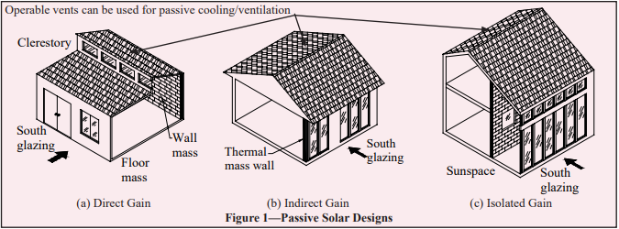

PASSIVE SOLAR DESIGN RULES OF THUMB
These rules of thumb should be used as a basis for a first step in identifying the building layout, sizing of the system, and building materials. These rules of thumb are also most appropriate for residential and small commercial buildings.
Rules of thumb include:
- Building orientation
- Buffer the north side of the building
- Match the solar heating system to the room use
- Include adequate thermal mass
- Distribute the thermal mass throughout the room
- Avoid “insulating” thermal mass
- Select an appropriate thermal mass color
- Choose appropriate glass
- Se appropriate window shading
- Landscaping
The figure below shows guidelines for sizing overhands to allow sunlight entry from mid-September through mid-March. (Step 9).
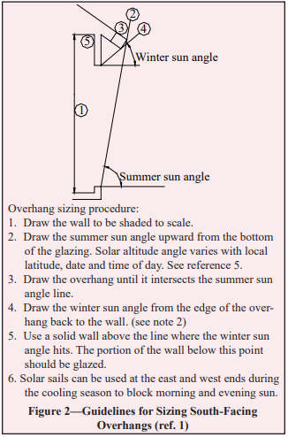

SOFTWARE TOOLS
To evaluate passive solar buildings, software should include an annual whole-building analysis that is able to correctly model solar gains and thermal mass. Specific recommended software and listed and briefly described in this TEK Note.

