Makayla Marr
TEK NOTE REVIEW: 06-04B – Energy Code Compliance Using COMCHECK ™
Updated 2012

INTRODUCTION
This TEK Note goes into depth of the different applications and uses of the program “COMcheck™”. COMcheck™ is a computer software that allows users to determine how their proposed building complies with the nationally recognized energy codes. This program was developed by the US Department of Energy. There are benefits to using this program as it may allow more flexibility within an engineer’s design in comparison to typical table requirements. Additionally, the program allows for selection of different national and state energy codes and standards.
In short, the program will generate a percentage “score” when all information about the building envelope is entered. This percentage allows users to quickly identify if their proposed building design “passed” or “failed” the selected building code requirement. The program is free and available online.

APPLICABILITY
Users will first select which code and year of publication to use for analysis of their design. The TEK note outlines all codes that are available for selection. COMcheck can be used for all buildings other than low-rise residential buildings in which the program “REScheck™” is used.

BUILDING ENVELOPE COMPLIANCE
Users will then input all building envelope information required by the program. Inputs are located on the “project” screen and information needed is outlined in sequential steps. Once complete, the software will then generate an output that combines the building envelope information with weather data in the program. The output is a pass/fail rating that will show in the bottom left of the screen and a percentage will also generate showing how close the proposed building is from meeting the selected building code requirements. Figure 1 shows an example of user application of the COMcheck software.
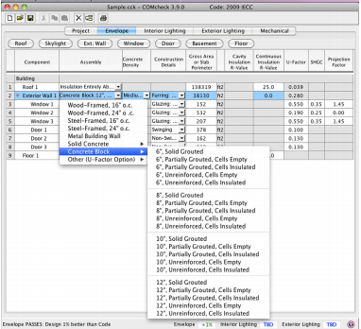

ABOVE-GRADE CONCRETE MASONRY WALLS
Because COMcheck contains a database of precalculated thermal properties for various systems, users do not have to input associated R-values. COMcheck includes a variety of selection for single wythe masonry walls with or without insulation in the ungrouted cells.
If the selection of walls needed is unavailable, users can input custom data to ensure validity of results. If more than one type of construction is used in the building, each construction type should be entered to also ensure legitimacy of results.

CONCRETE MASONRY BASEMENT WALLS
When selecting basement walls in COMcheck, users will select the same walls as those listed for above grade walls.

ADDITONAL MANDATORY REQUIREMENTS
In addition to meeting energy code requirements, COMcheck also ensures mandatory requirements are met as well. Users can find the mandatory requirements under the View tab.
LIGHTING AND MECHANICAL COMPLIANCE
Mechanical, lighting, and envelope compliance are independent from each other in the program.

