Makayla Marr
TEK NOTE REVIEW: 06-02C – R-Values and U-Factors of Single-Wythe Concrete Masonry Walls
Updated 2013

INTRODUCTION
Single wythe concrete masonry construction is commonly constructed using hollow units with cores filled with insulation and/or grout. A wythe is a vertical layer of masonry that is one unit thick. This construction system allows for the addition of insulation and reinforcement without an increase to the overall wall thickness. The insulation and reinforcement are used to increase the overall thermal resistance and structural performance.
Steady-state conditions of single wythe systems can be estimated by R-values (thermal resistance) and U-factors (thermal transmittance). This Tek note shows the thermal resistances and thermal transmittances of a variety of single wythe wall configurations determined using the code-recognized series-parallel method. This method considers energy loss through the webs of typical concrete masonry units, as well as the insulation layers.

CONCRETE MASONRY ENERGY PERFORMANCE
The Tek Note points out that the R-values or U-factors of a concrete masonry wall assembly do not fully describe the thermal performance of these walls. The thermal performance depends on both the steady-state thermal characteristic (R-value and U-factor) and the thermal mass or heat capacity characteristics. These characteristics are influenced by the size, type and configuration of the masonry unit, type and location of the insulation, finish materials, density of masonry, climate, and building orientation or exposure conditions.
The thermal mass of a system describes the ability of materials to store energy. Masonry provides effective thermal storage as it has a high density and specific heat in comparison to other materials typically used in exterior wall systems. This thermal mass of the masonry acts to maintain a steady temperature which regulates indoor temperature. Because of this, concrete masonry assemblies require less insulation than equivalent light frame systems.
Concrete masonry may require more insulation in order to achieve desired thermal performance even if the R-value and U-factor meets code requirements.
It is also important to not associate a high R-value with a greater energy efficiency. In general terms, higher R-values reduce energy flow through building elements, but they also have a diminishing impact on the overall building envelope energy use. This is a manifestation of the inverse relationship (U = 1/R) between U-factor (the amount of energy moving through the wall) and R factor (the steady state thermal resistance).
Figure 1 Shows that as the R-value of a wall increases, there is less of an impact on the building envelope thermal performance, at higher R values. Typically doubling R values beyond about R 12 – 15 has very little impact on the thermal performance of exterior wall systems (1% – 5%)
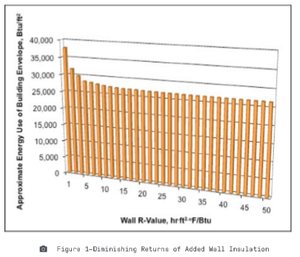

ENERGY CODE COMPLIANCE
If prescriptive insulation requirements are used for code compliance, continuous insulation of concrete masonry and other mass walls are required.
CONCRETE MASONRY UNIT CONFIGURATIONS
The minimum amount of web material required for CMU has significantly decreased with the new revisions in the 2011 ASTM C90 Standard Specification for Loadbearing Concrete Masonry Units. But the new revision allows a wider range of web configurations. These new configurations have changed R-values and U-factors due to the decrease in the area of the web. Because the webs act as thermal bridges, the decrease in area increases the corresponding R-value and U-factor.
The R-values in Table 2 are based on a unit height of 8 inches but the R-value varies little with the change in unit height therefore individuals can apply the R-value to different unit height of the same unit.
Table 1 lists unit configurations to calculate values in Table 2. Each unit has three full height webs. Below is Table 1: Unit Dimensions.
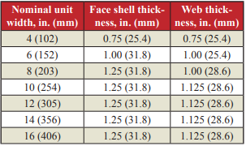

U-FACTOR AND R-VALUE TABLES – TRADITIONAL THREE-WEB UNITS
In Table 2, the calculated U-factors and R-values are listed for different masonry wall thicknesses, concrete densities of 85 to 135 lb/ft³, and for various core fills.
Table 2 is shown below: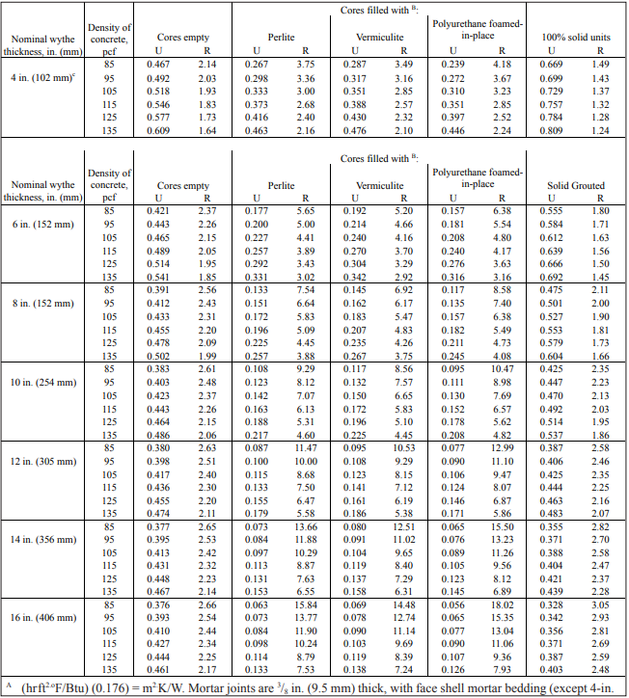
To determine R-values of partially grouted walls, Table 3 provides percentages of grouted and ungrouted wall area. Table 3 also shows values for vertical and horizontal grout spacings.

Table 3 shown below:
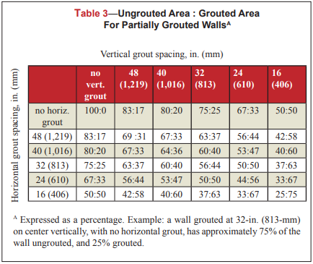
The values listed for insulated and grouted cores in Table 2 can be used directly for concrete masonry wall cores that are fully grouted or insulated.
Table 4 lists R-values of different interior and exterior insulation and finish systems that can be added directly to the R-values listed in Table 2. Table 4 is shown below:
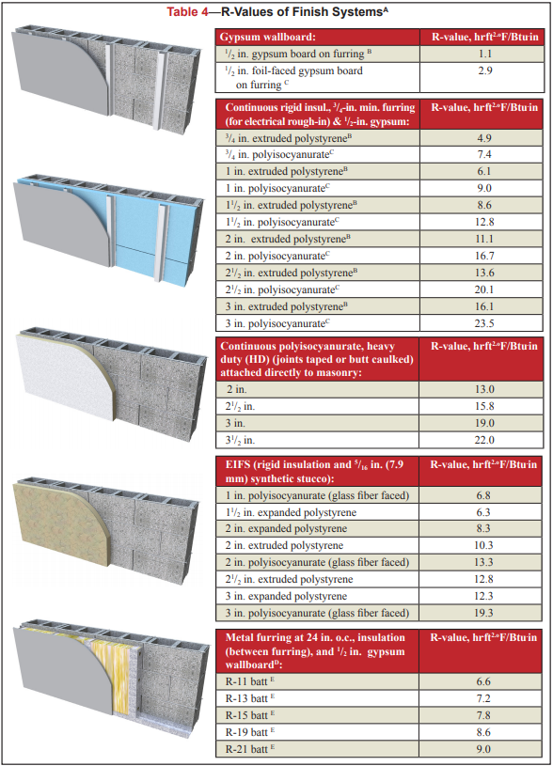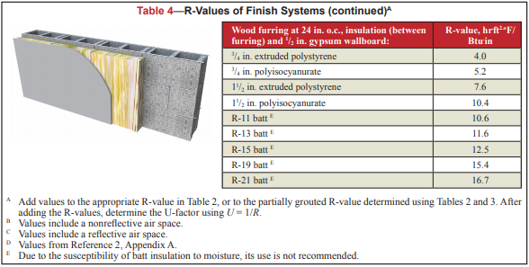
The associated thermal properties used to generate the tables are shown in Table 5. Table 5 is shown below:
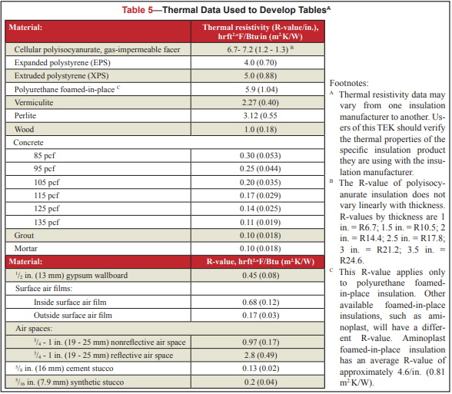

R-VALUES AND U-FACTORS OF PARTIALLY GROUTED CONCRETE MASONRY
If concrete masonry walls are partially grouted, values in table 2 cannot be used directly. R-values must be modified using an area-weighted average approach. The following equation details how to find the modified R-value and U-factor. Use Table 3 to find how much of the core is grouted.
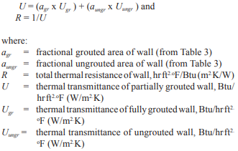
Once determining the modified R-value, use Table 4 to add the additional R-value. Table 4 R-values do not need to be modified.

