Makayla Marr
TEK NOTE REVIEW: 06-01C – R-Values of Multi-Wythe Concrete Masonry Walls
Updated 2011

INTRODUCTION
Multi-Wythe concrete masonry construction is a commonly constructed exterior masonry wall system . A wythe is a vertical layer of masonry that is one unit thick. Multi-wythe indicates that multiple masonry layers are used and spaced apart so there is an airspace or cavity between the wythes. Commonly, insulation is placed between two wythes of masonry, offering maximum protection of the insulation and good thermal wall resistance. These wall systems can be designed to meet or exceed energy code requirements because the cavity between the two wythes allows for a continuous layer of insulation to be developed in the exterior masonry walls. The insulation layer increases energy efficiency and can decreases air infiltration and exfiltration through the walls.
The thermal resistance (R) values associated with multi-wythe walls, as well as single wythe R-values. R-values can be determined by a number of analytical methods. This Tek note shows the thermal resistances of a variety of multi-wythe wall configurations determined using the code-recognized series-parallel method. This method considers energy loss through the webs of typical concrete masonry units, as well as the insulation layers. Also listed in this Tek Note are typical R values for various wall materials.

CAVITY WALLS
The term cavity insulation and masonry cavity wall are two different terms that are often confused with one another. Cavity insulation refers to the insulation between studs in lightweight framing systems whereas masonry cavity walls are comprised of at least two wythes of masonry and separated by an airspace (or cavity).
Current building code requires a clear airspace of 1 inch between the insulation and the outer wythe. But a clear space of 2 inches is preferred as it helps to ensure free water drainage. When designed, cavity walls are typically designed and detailed using “out-to-out” dimensions. The most common type of Cavity wall has a wythe of 4 inch nominal brick veneer backed by a wythe of 8 inch nominal concrete block units.
This Tek note indicates that the R-value of a multi-wythe assembly does not change significantly with the change of the interior finish material unless the material is insulative.

CONCRETE MASONRY ENERGY PERFORMANCE
The Teck Note points out that the R-values or U-factors of a concrete masonry wall assembly do not fully describe the thermal performance of these walls. The thermal performance depends on both the steady-state thermal characteristic (R-value and U-factor) and the thermal mass or heat capacity characteristics. These characteristics are influenced by the size, type and configuration of the masonry unit, type and location of the insulation, finish materials, density of masonry, climate, and building orientation or exposure conditions.
The thermal mass of a system describes the ability of materials to store energy. Masonry provides effective thermal storage as it has a high density and specific heat in comparison to other materials typically used in exterior wall systems. This thermal mass of the masonry acts to maintain a steady temperature which regulates indoor temperature. Because of this, concrete masonry assemblies require less insulation than equivalent light frame systems.
It is also important to not associate a high R-value with a greater energy efficiency. In general terms, higher R-values reduce energy flow through building elements, but they also have a diminishing impact on the overall building envelope energy use. This is a manifestation of the inverse relationship (U = 1/R) between U-factor (the amount of energy moving through the wall) and R factor (the steady state thermal resistance).
Figure 1 Shows that as the R-value of a wall increases, there is less of an impact on the building envelope thermal performance, at higher R values. Typically doubling R values beyond about R 12 – 15 has very little impact on the thermal performance of exterior wall systems (1% – 5%)
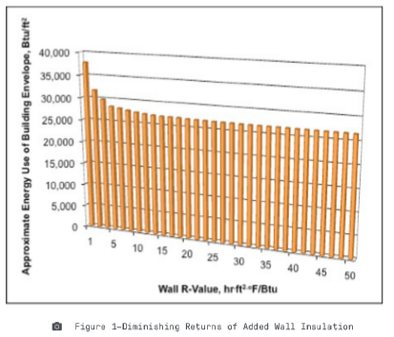

ENERGY CODE COMPLIANCE
If prescriptive insulation requirements are used for code compliance, continuous insulation of concrete masonry and other mass walls are required. However , U factor analysis , testing and holistic building energy analysis can be used show energy code compliance for wall systems without continuous insulation.
Typical parallel and series analysis for a typical concrete masonry unit is shown in Figure 2.
- 