Task: Find the R-value and U-factor for a 2-web fully grouted CMU block following a Series-Parallel R-Value Calculation. Assume: Assembly 1-1 – 8” x 8” x 16” 105 lb/ft³ with CMU Unit length = 15.625 in, Unit Width = 7.625 in, Unit Height = 7.625 in, Mortar Joint Thickness = 0.375 in, Thickness of Web = 1 in.
Start: Reference NCMA Tek Note 06-01C for a brief description of the Series-Parallel R-value Calculation. The image below can be found in the Tek Note and shows the formula used in the Series-Parallel R-value Calculation as well as what each variable in the formula represents.
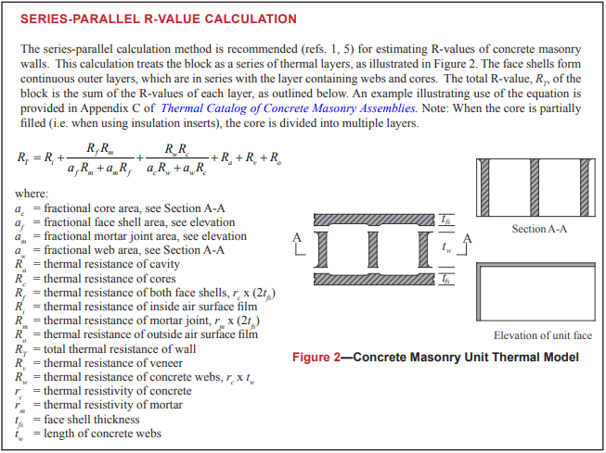

- From assumptions listed in the Task, list and/or calculate the face shell thickness, length of concrete web.
- List and/or Calculate the thermal resistivity of mortar, concrete, air, polyurethane, outside air film, and inside air film. These values can be found in Table 5 of NCMA Tek Note 06-01C OR calculated with the following equations below.
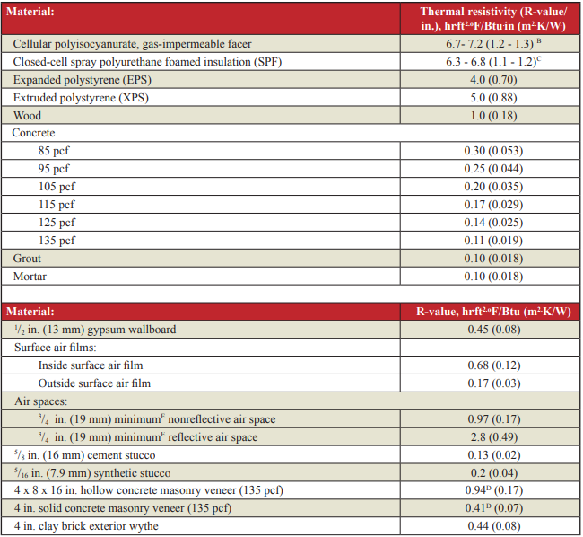

- Calculate the Area of the Web
$$=\frac{2 x 7.625 x 1}{\left(15.625+0.375\right) x (7.625+0.375)}=\frac{15.25}{128}=0.119 \%$$

- Calculate the Area of the Core
$${Area}_{core}=1-{Area}_{webs}=1-0.119=0.881\%$$

- Calculate the Area of the Face
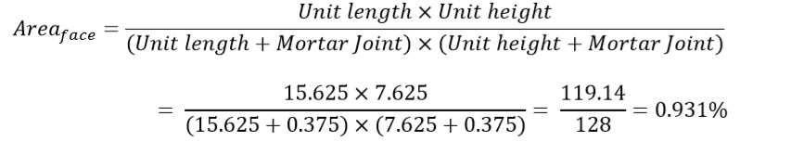

- Calculate the Area of the Mortar
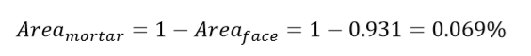

- Calculate the R-value of the Face.
- Calculate the R-value of the Mortar.

- Calculate the R-value of the Web.
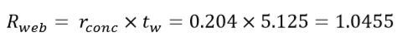

- Calculate the R-value of the Core.
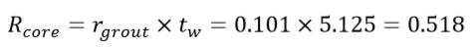

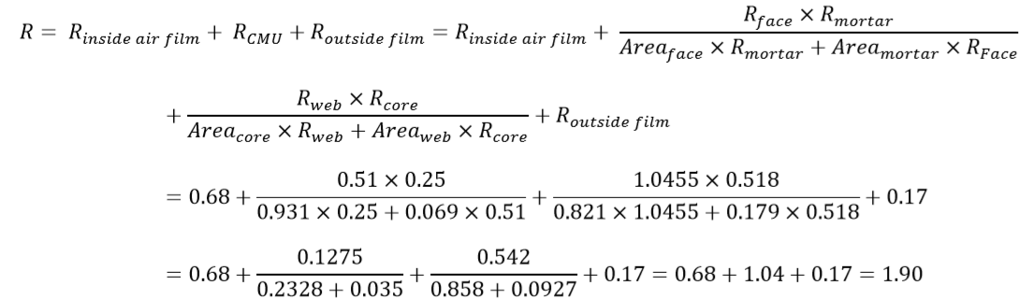
- Plug all values in the Series-Parallel Equation provided by the Tek Note.
1.86
1.01
0.921
0.881

- Find the U-factor:

$$U ̵Factor= \frac{1}{R-value}=\frac{1}{1.86}=0.537$$

End: The R-value of an Assembly 1-1 – 8” x 8” x 16” 105 lb/ft³, 2-web CMU is 1.86 and the U-factor is 0.537.

