EnergyPro 8: How-To Guide

MODELING GUIDES
The support section on the EnergyPro website gives numerous resources including a Modeling Guides section that includes a Getting Started guide for both Residential and Nonresidential projects.
- All models and guides can be found at the following link: http://www.energysoft.com/support/modeling-guides/
Detail of each model is as follows:
- VPF Mechanical Systems Guide
Summary: This 15-page guide to model variable refrigerant flow systems (VRF) is detailed for version 5 of the EnergyPro Software. The guide starts with a brief introduction of the applicability of HVAC systems and their efficiency in relation to the compliance software system, a concise overview of the VRF system, common applications, special considerations, modeling and input approaches, results, and finally, discussion of how to optimize energy efficiency of a VRF system.

- Underfloor Air Distribution System Example
Summary: This 1-page guide provides 4 screenshots from the EnergyPro software with descriptions of what each input selection represents. The descriptions give guidance as to what inputs are typically selected or inputted.

- Displacement Ventilation Example
Summary: This 1-page guide provides 3 screenshots from the EnergyPro software with descriptions of what each input selection represents. The descriptions give guidance as to what inputs are typically selected or inputted.

- YGrene Commercial EnergyPro Quick Start Guide
Summary: This 64-page guide provides 16 detailed chapters in relation to the EnergyPro software and Commercial building applications. The sections are as follows:
- EnergyPro Software Information
- EnergyPro Process Overview
- Commercial Project Eligibility
- Create a new EnergyPro – Nonresidential Building Wizard
- Create a new EnergyPro – New Nonresidential File
- Building Level: Whole Building Icon
- Plant Level: DHW Icon
- System Level: HCAC Icon
- Zone Level: Multiple Rooms Icon
- Room Level: Single Room Icon
- Assembly Level: Slab, Raised Floor, Exterior Walls, Roof
- Room Features Level: Windows, Doors, Skylights
- Completing the Alternatives Tab
- EnergyPro Reports and Reporting Energy Data
- Two-model Simulations
- Common EnergyPro Errors

- YGrene Residential EnergyPro Quick Start Guide
Summary: This 64-page guide provides 16 detailed chapters in relation to the EnergyPro software and Residential building applications. The sections are as follows:
- EnergyPro Software Information
- EnergyPro Process Overview
- Residential Project Eligibility
- Create a new EnergyPro – Home Rating Wizard
- Create a new EnergyPro – New Residential File
- Building Level: Whole Building Icon
- Plant Level: DHW Icon
- System Level: HVAC Icon
- Zone Level: Multiple Rooms Icon
- Room Level: Single Room Icon
- Assembly Level: Slab, Raised Floor, Exterior Walls, Roof
- Room Features Level: Windows, Doors, Skylights
- Completing the Alternatives Tab
- EnergyPro Reports and Reporting Energy Data
- Two-model Simulations
- Common EnergyPro Errors

SUPPORT SECTION PROJECT FILES
The support section on the EnergyPro website also gives Example Project files that show how to model different buildings and mechanical systems.
Example Project Files include:
- Bard AC (Library of Bard Air Conditioners)
- Bard HP (Library of Bard Heat Pumps)
- Blomberg Example (Library of Blomberg Windows)
- Chilled Beams (Example of Chilled Beam Modeling)
- Daikin VRV IV (Library of Daikin VRV series IV equipment)
- DOAS (Dedicated Outdoor Air System example)
- Env Pres Example (example showing Prescriptive compliance for just the Envelope)
- Existing Addition/Alteration (ADU being added to a home with new tankless DHW and Mini-Split)
- Fujitsu Example (library of Fujitsu VRF and Mini-Split equipment)
- GPR Single Family Example (Green Point Rated example)
- Highrise Combo Hydro (note combined hydronic boiler at plant – DHW level of tree)
- Highrise Res Electric (demonstrates the use of electric baseboard heating under the Distribution tab)
- Highrise Res Hydronic (note hydronic boiler at plant level of tree)
- Hitachi VRF (library of Hitachi VRF equipment)
- Home Performance Sample (existing home with performance upgrades)
- Indoor Lighting Sample (Prescriptive example, Indoor Lighting compliance)
- Indoor Lighting Alteration (Prescriptive example, Indoor Lighting Alteration)
- Lennox VRF (library of Lennox VRF equipment)
- LG AC VRF (library of LG Air Cooled VRF equipment)
- LG WC VRF (library of LG Water Cooled VRF equipment)
- Low-rise Combined Hydronic (Single Family home with single boiler providing space heat and DHW)
- Low-rise Res Separate DHW & Hydro (Single Family home with separate boilers providing space heat and DHW)
- Mech Pres Example (compliance Prescriptively for Mechanical only)
- MF Example (Multi-Family project)
- Mitsubishi AC VRF (library of Mitsubishi Air Cooled VRF equipment)
- Mitsubishi WC VRF (library of Mitsubishi Water Cooled VRF equipment)
- Nonres Built-up VAV (Chilled Water Variable Air Volume System)
- NonRes Sample (three zone mixed use building – demonstrates most features in software)
- Outdoor Lighting (good template to use when creating outdoor lighting projects)
- Outdoor Lighting Alteration (Alteration to Outdoor Lighting)
- Residential Basement (note the Story inputs at the Zone level of the tree)
- Res Mini-Split Example (note the Mini-Split Heat Pump input at the System level of the tree)
- Res Sample (Two story home with attached Garage)
- Res Zonal Example (Zonally Controlled HVAC with separate Living and Sleeping inputs at the Zone level of the tree)
- Samsung AC Example (library of Samsung VRF equipment)
- Tailored Lighting (demonstrates mixed lighting (area category and tailored for retails spaces)
- TES Example (non-T24 example modeling Thermal Energy Storage)
- Toshiba/Carrier VRF (library of Toshiba/Carrier VRF equipment)
- WSHP Example (Water Source Heat Pump Example)
- York VRF (library of York VRF equipment)
- ZNE Example (Zero Net Energy example including a Ground Coupled HP system)
- ZNE Senior Housing (Zero Net Energy example for large Senior Housing project)
These Example Project files can be found at the following link: http://www.energysoft.com/support/samplefiles/

BUILDING WIZARDS
In the EnergyPro software, under the File menu item, you can use the building wizard to create a basic model. There are 3 different building wizards that can be used to create the building. Once the basic building is created using the wizard, you can go directly into the building tree and you will have more selections and options of items to add.
START: OPENING SCREEN
CLICK “FILE” AND FIND THE THREE BUILDING WIZARDS ENTITLED “Residential Building Wizard”, “Home Rating Wizard”, or “Nonresidential Building Wizard”. Select the one that matches your project.
RESIDENTIAL BUILDING WIZARD Steps:
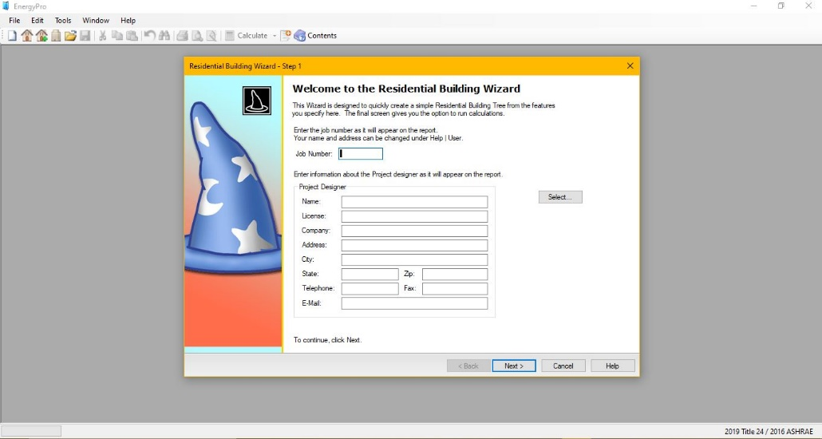

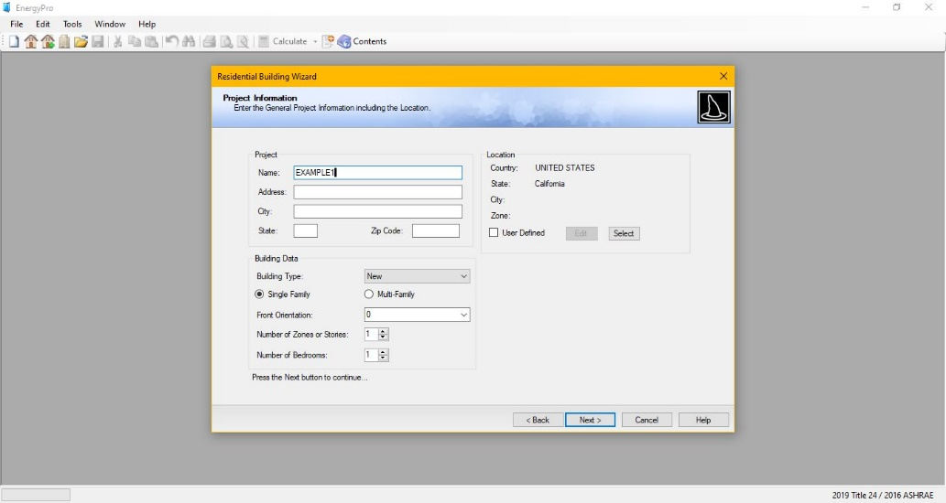

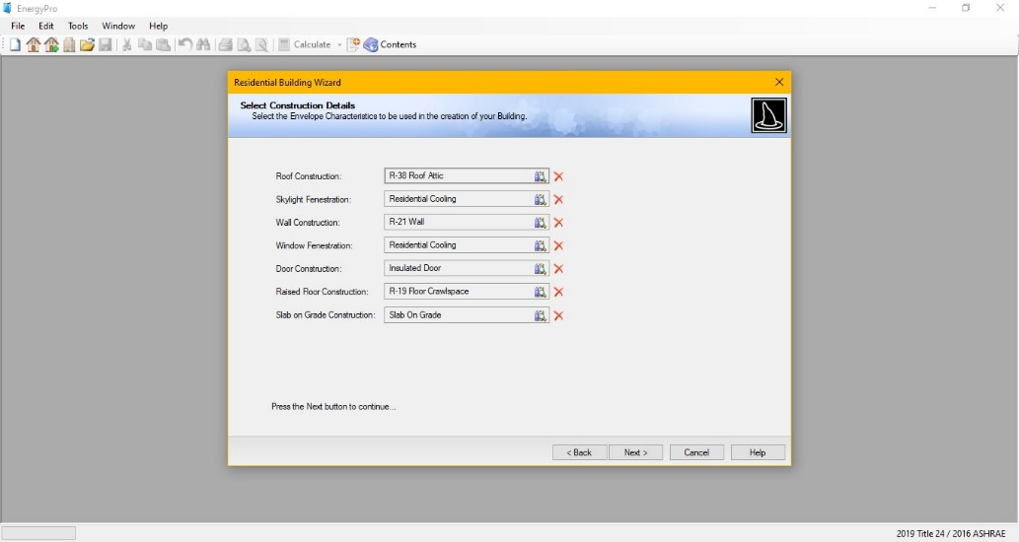
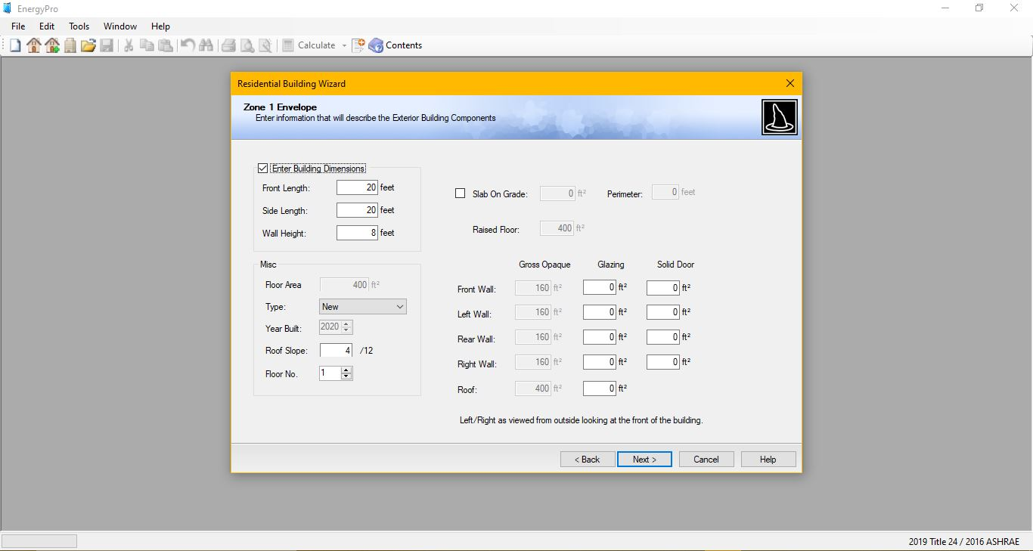

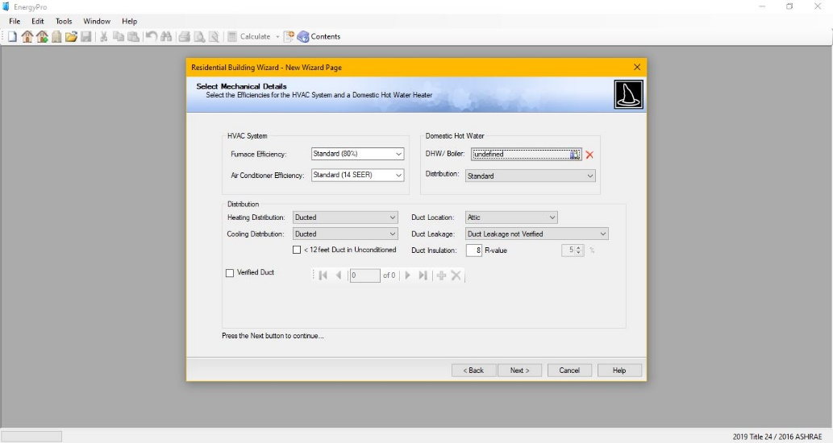

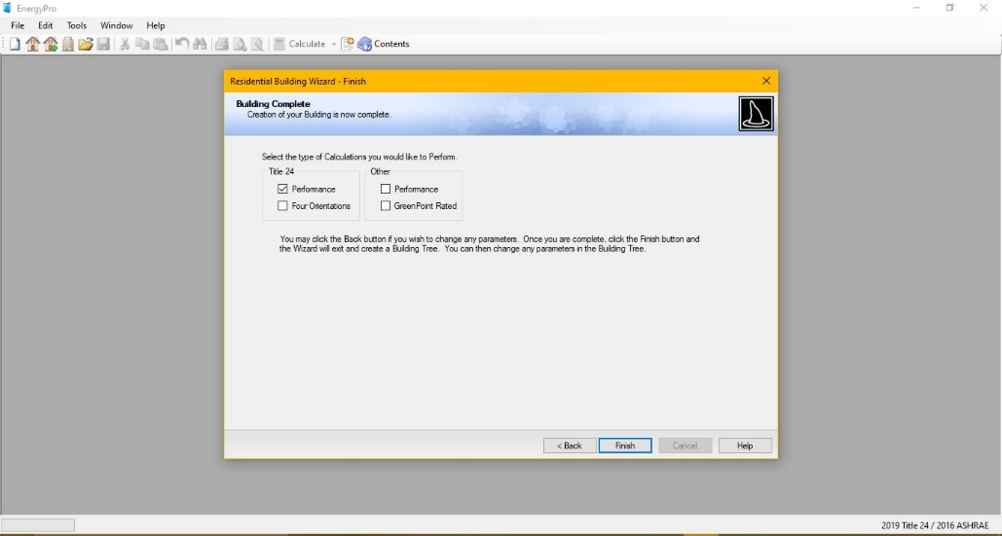

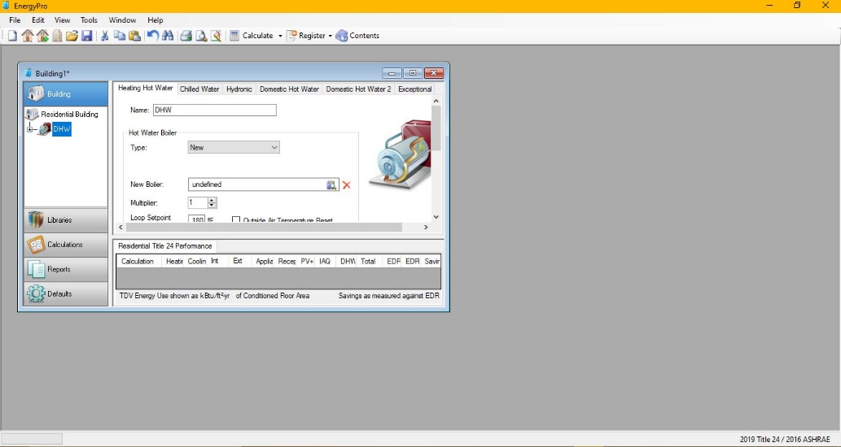

HOME RATING WIZARD Steps:
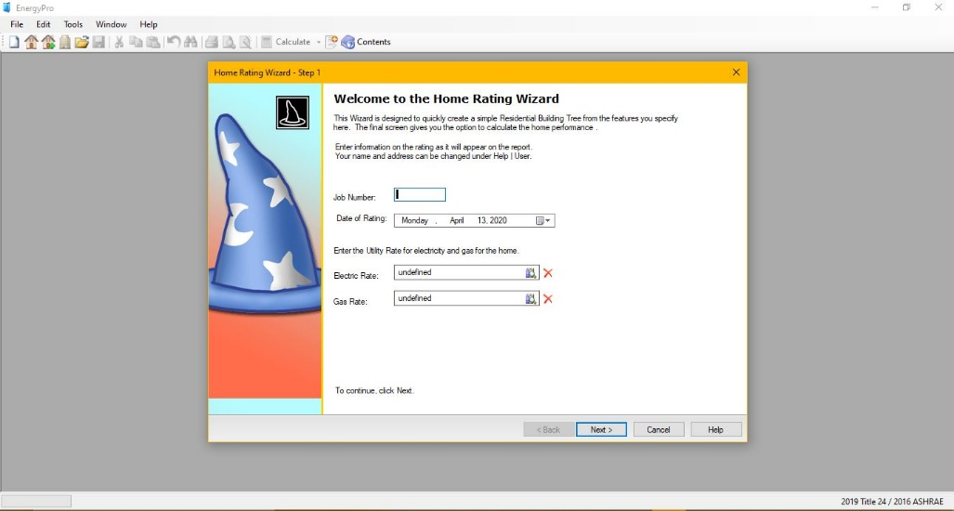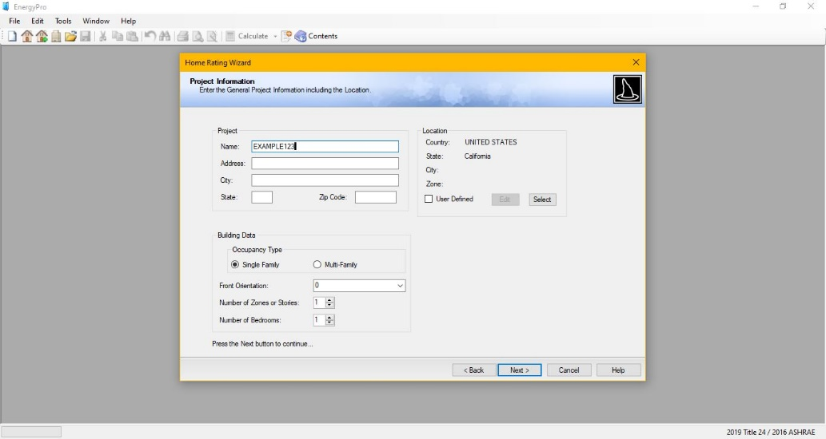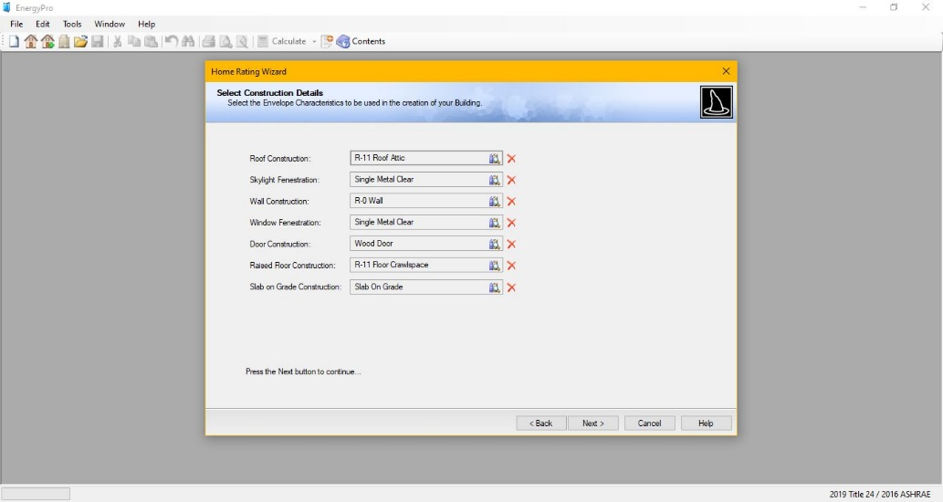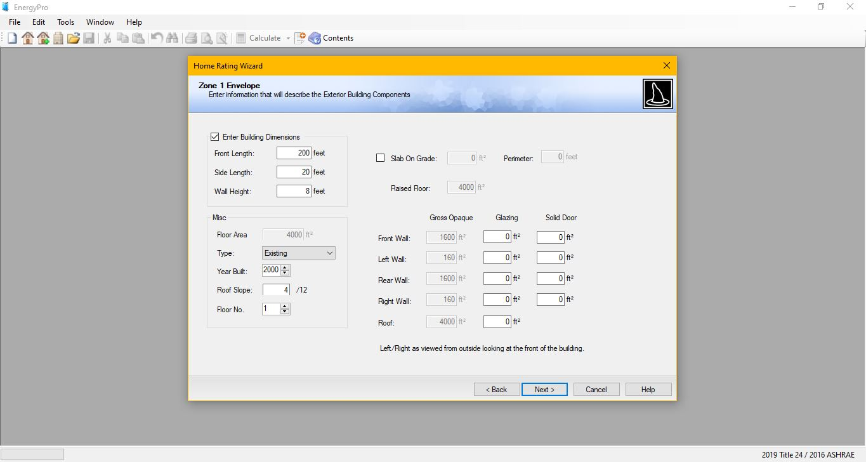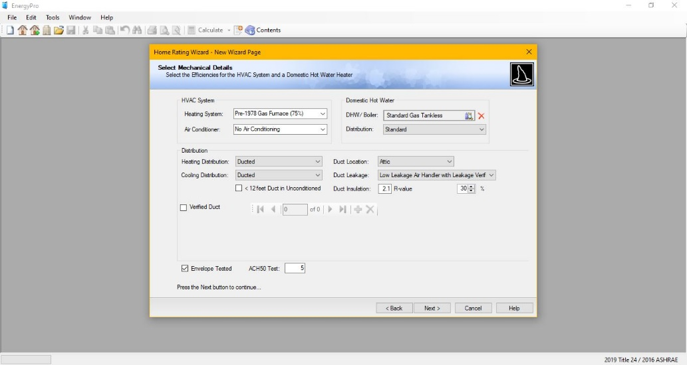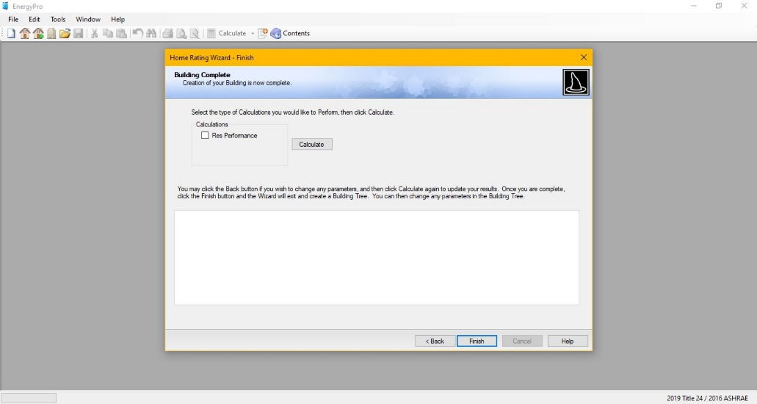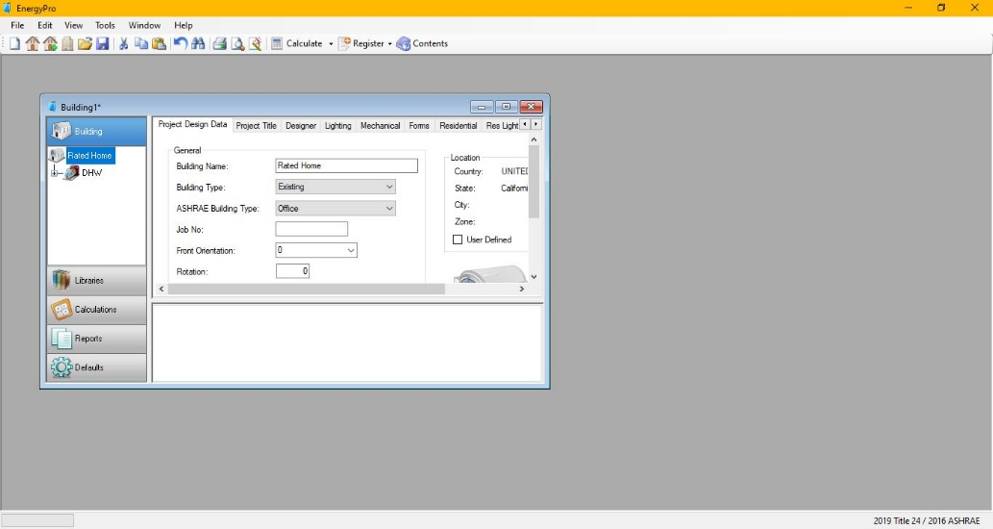

NONRESIDENTIAL BUILDING WIZARD Steps:
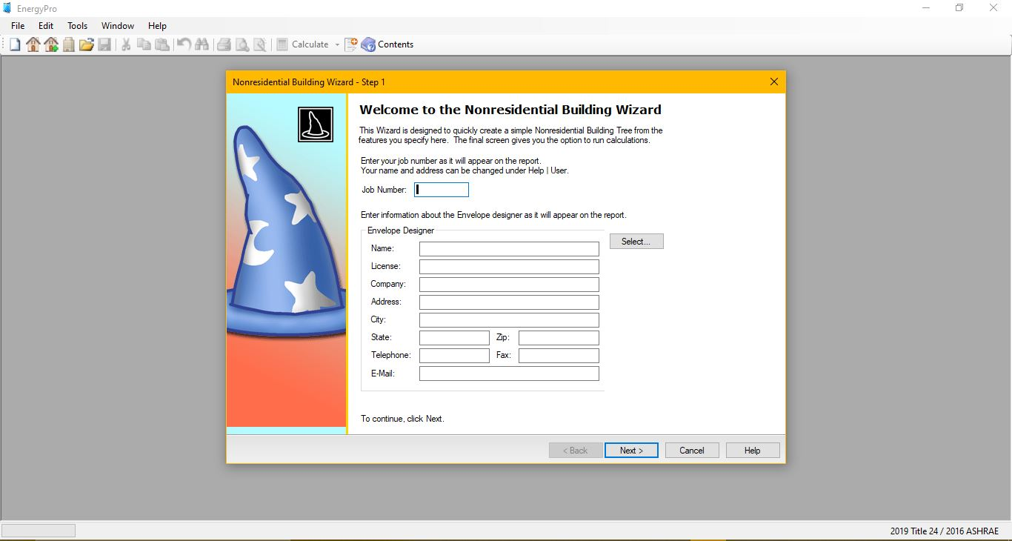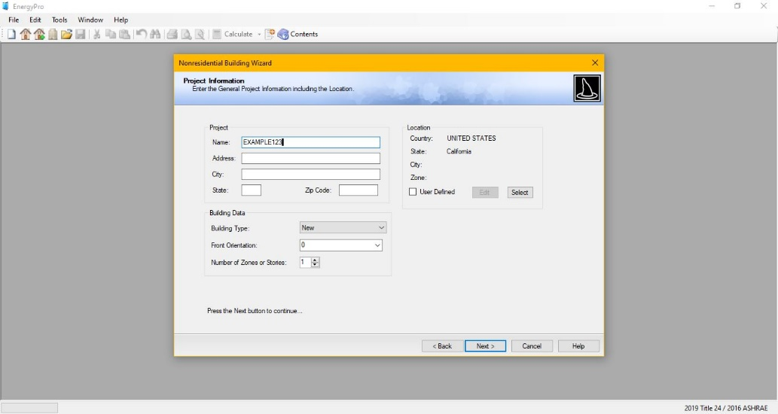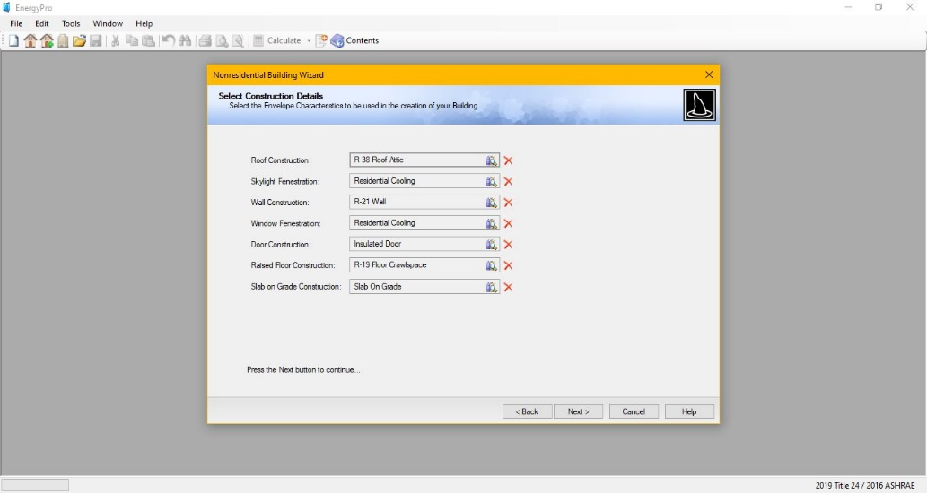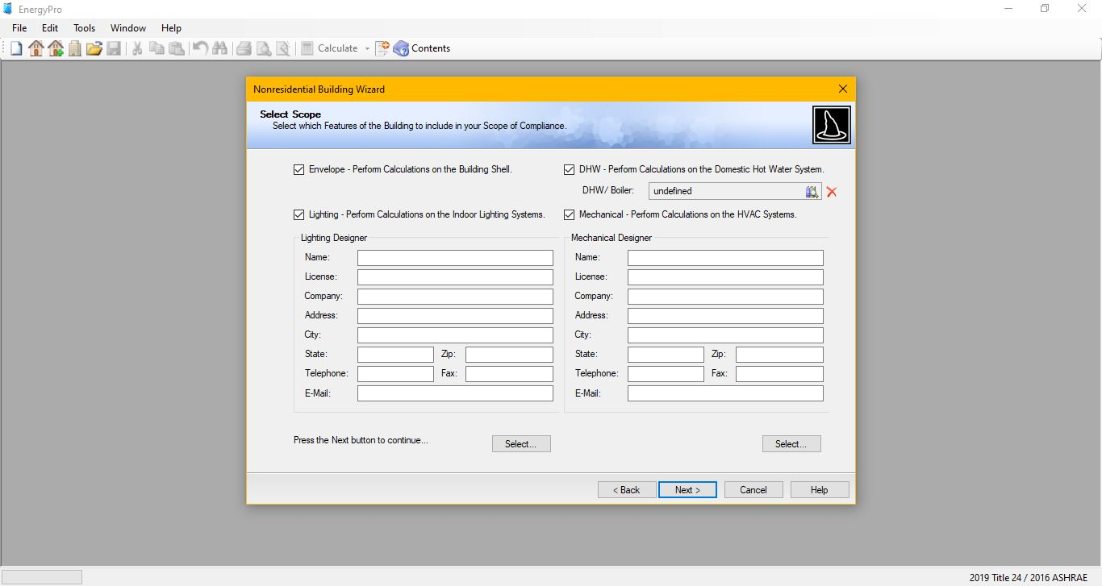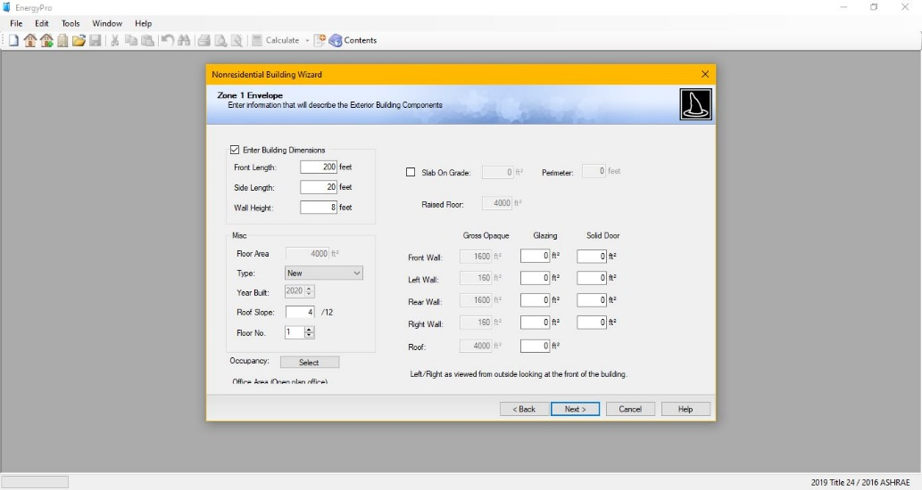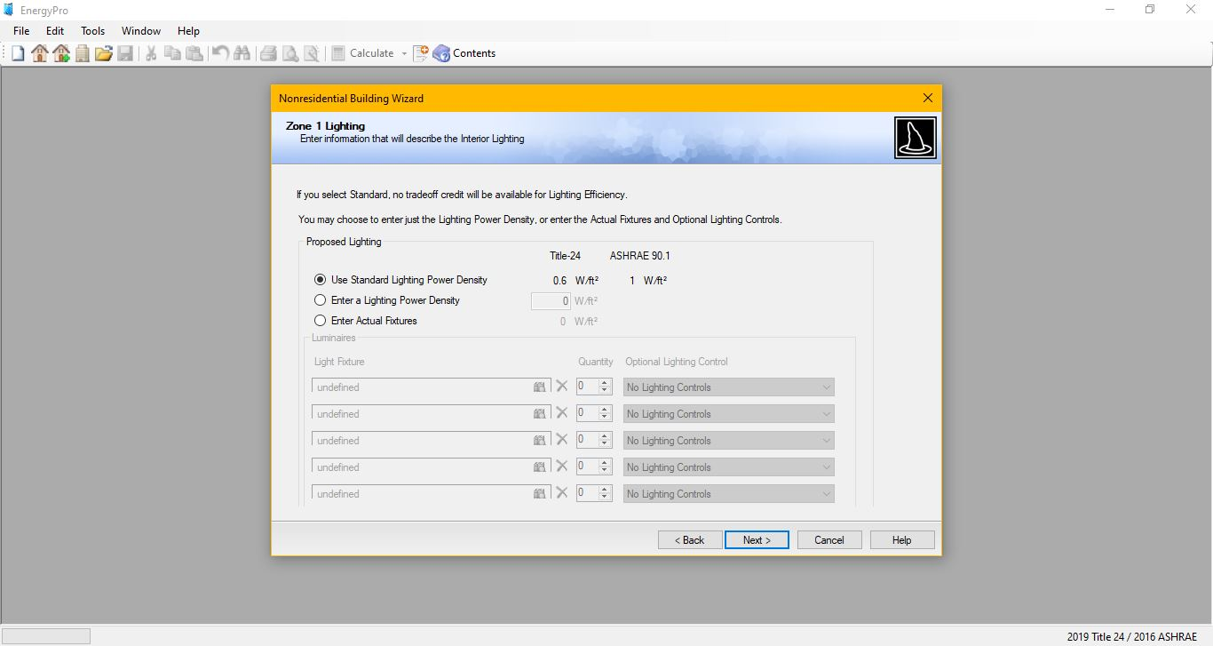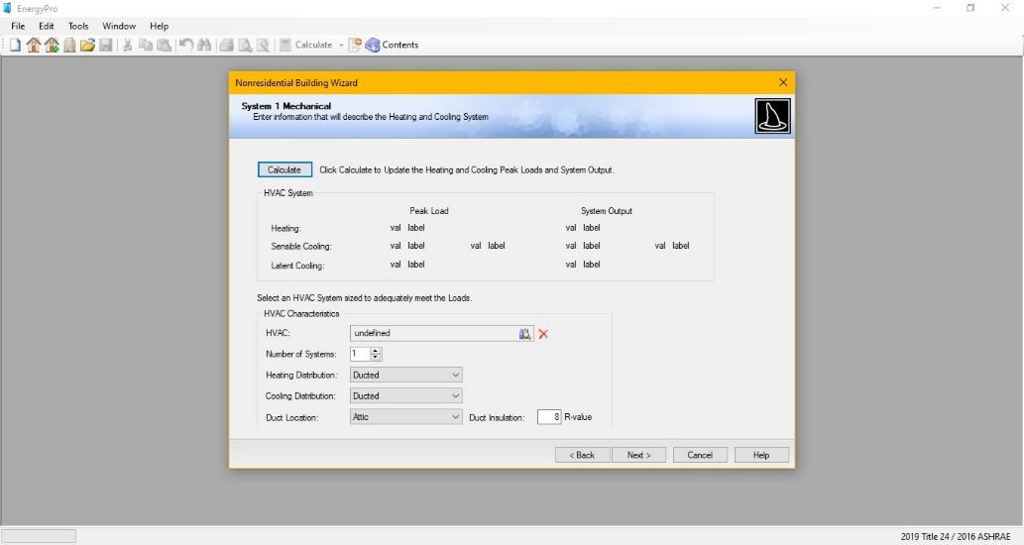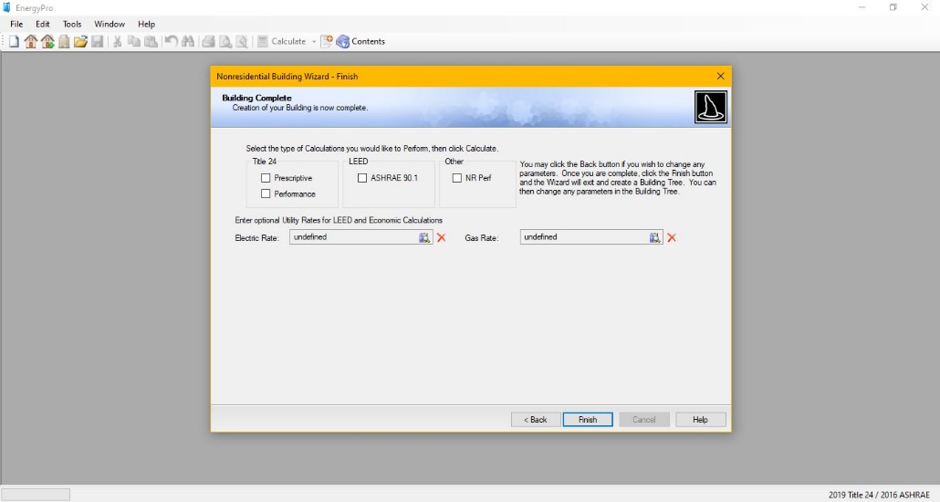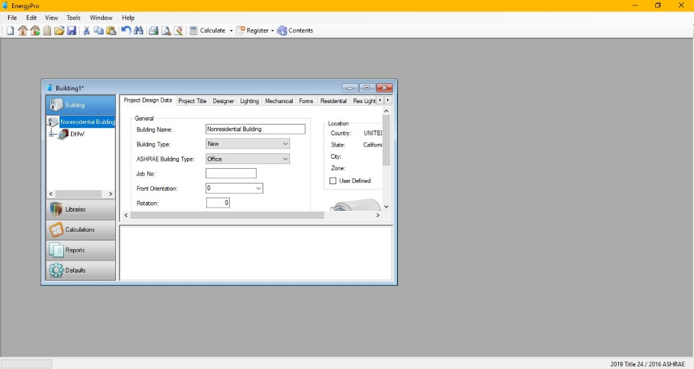

HELP KEY
If you have any questions about a certain input in the software, you can click on the input and press the “F1” key on your computer that will then prompt a help window to appear with an explanation of what belongs in the input.
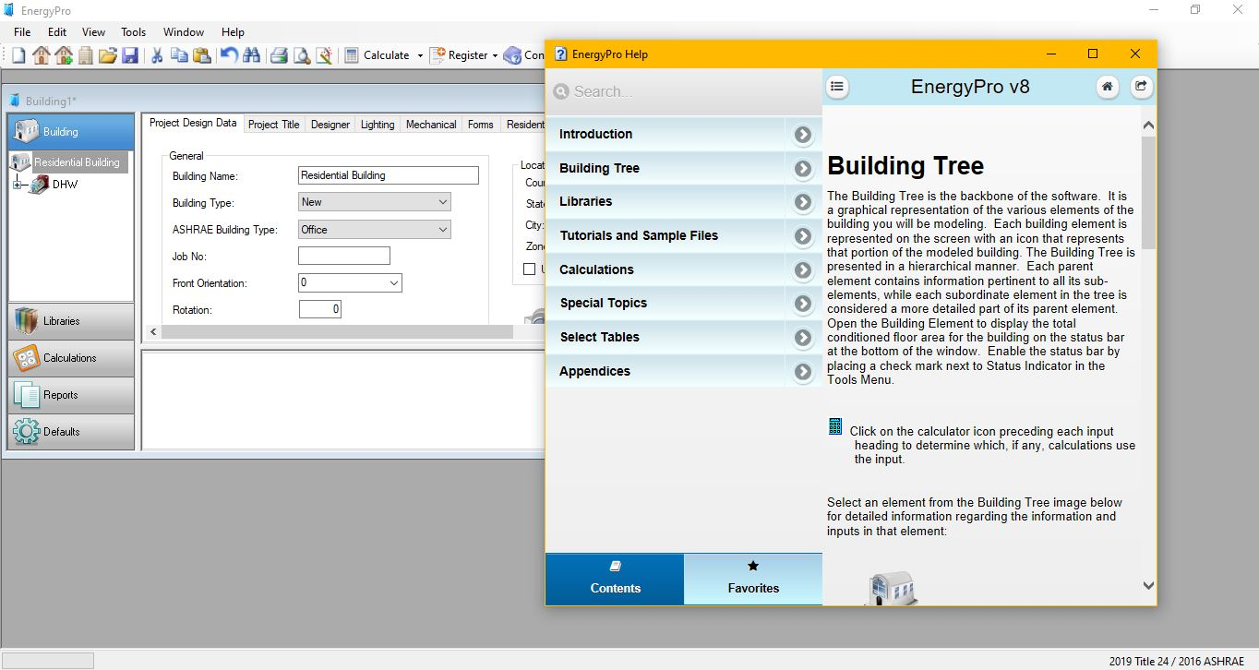

YOUTUBE VIDEO TUTORIALS:
- “Getting Started with EnergyPro”
  - https://www.youtube.com/watch?v=Yri61Nb5NNY&feature=youtu.be
- “Modeling Overhangs”
  - https://www.youtube.com/watch?v=Pjh32qv4pNc
- “Advanced HVAC and DHW”
  - https://www.youtube.com/watch?v=4KMh2yQXadQ&feature=youtu.be
- “Modeling a Two-Story House”
  - https://www.youtube.com/watch?v=RvX1PieUifE&feature=youtu.be
- “Modeling Existing + Addition/Alteration”
  - https://www.youtube.com/watch?v=E1qg5M1iagc
- “Modeling a Townhouse”
  - https://www.youtube.com/watch?v=kZeNicRINtg&feature=youtu.be

