EnergyPro Version 8 Summary (Source EnegyPro8 user Manual)
EnergyPro is a commercial software product that is available to users via subscription and a fee. EnergyPro is an energy analysis software that may be used to document compliance with California’s 2019 Residential and Nonresidential Building Energy Efficiency Standards (Title 24, Part 6). EnergyPro specializes in building energy performance modeling and is the only commercial software approved for 2019 Nonresidential and Residential buildings. ASHRAE 90.1 Standards, as well as residential and nonresidential Green Building rating systems, such as GreenPoint Rated, and LEED are also integrated into the system.
EnergyPro is the only software package to generate the new California Energy Commission (CEC) 2019 online Prescriptive forms. The software is made up of an interface that includes an interactive “Building Tree”, different Libraries and residential and nonresidential calculation models.
The 2019 Building Energy Efficiency standards can be found at https://www.energy.ca.gov/programs-and-topics/programs/building-energy-efficiency-standards/2019-building-energy-efficiency. The website gives a comprehensive understanding of the requirements specific to the input functions in the software.
EnergyPro also offers free training classes and seminars to allow users to get familiar with the new technology.
Some limitations of the software include:
- EnergyPro version 8 is designed for the 2019 code which has considerably more stringent code requirements with respect to energy performance.
- To download, this software requires 64-bit windows operating system (windows 10), hard disk: 1 GB of free space, Ram: 4 GB, and high-speed internet connection for downloading updates and issuing certificates of compliance.
Modules and Calculations
Source: EnergyPro8 Manual
EnergyPro incorporates many calculation models containing Residential and Nonresidential Performance modules as well as Load Calculation Models. These can be purchased as packages or separately, generally categorized as “Title 24 Modules” and “Other Calculations”. More information can be found I the EnergyPro8 Manual.
When a user creates a building description file, the user can select which calculations to run. The Title 24 Modules include: Residential Title 24 Prescriptive, Residential Title 24 Performance, Residential Loads, nonresidential Title 24 Prescriptive, Nonresidential Title 24 Performance, Nonresidential Title 24 Process, and Nonresidential Title 24 Mandatory Measures. The Other Calculations modules include Lowerise Residential Performance, GreenPoint Rated, Residential Load Calculations, Nonresidential Performance, ASHRAE 90.1 Performance Compliance, and Nonresidential Loads.

For more information and an interactive information guide, open EnergyPro and go to the “Help” tab and click “Contents”.
“User Interface:
EnergyPro’s user interface provides an intuitive method of simulating both residential and nonresidential buildings for Title 24 compliance as well as many other purposes, including compliance with ASHRAE 90.1, and documenting green building ratings. The format is the product of development and refinement over several code cycles resulting in an efficient, easy-to-use, and flexible interface.”
“Res T24 Prescriptive Calculation:
The Res T24 Prescriptive module is a computerized version of the Residential Prescriptive method for additions and alterations. The module automatically ascertains if a project meets the prescriptive requirements and completes the forms required for registration and building department submittal. Because there are no tradeoffs or substitutions in the Prescriptive Approach, and each element of the project must meet the minimum requirement, the module doesn’t perform a simulation, or provide any calculation options. The software does perform some calculations, such as calculating the maximum allowed window area, and weighted average U-factors.
“Res T24 Prescriptive Reports EnergyPro’s
Res T24 Prescriptive module creates the forms required for HERS registration (if necessary) and for submittal to the building department. You may create a Res T24 Prescriptive report irrespective of the calculation results, but EnergyPro will print a watermark indicating that the project does not comply if any of the project features fail to meet the minimum prescriptive requirement. The Res T24 Prescriptive report contains one of the following compliance forms, depending on the project scope: CF1R-ADD-02-E – Additions 1,000 ft2 or less, or Additions that do not require HERS verification CF1R-ALT-05-E – Alterations that do not require HERS verification EnergyPro will also create the files required to register addition or alteration projects that do require HERS verification. EnergySoft has created detailed instructions on registering projects with a HERS Provider to help you through the process.”

Example of Energy Pro8 use for the design a residential masonry building using the prescriptive method. Showing typical errors and solutions
In the EnergyPro software, under the File menu item, you can use the building wizard to create a basic model. There are 3 different building wizards that can be used to create the building. Once the basic building is created using the wizard, you can go directly into the building tree and you will have more selections and options of items to add.
- START: OPENING SCREEN

- CLICK “FILE” AND FIND THE THREE BUILDING WIZARDS ENTITLED “Residential Building Wizard”, “Home Rating Wizard”, or “Nonresidential Building Wizard”. Select the “Residential Building Wizard”.

- Welcome to the Residential Building Wizard. Start by filling out the project description. If there is information you do not have for your project, you can leave them blank. For this example, we simply put “Example” in fields. Once completed, select “Next” at the bottom of the pop-up window.
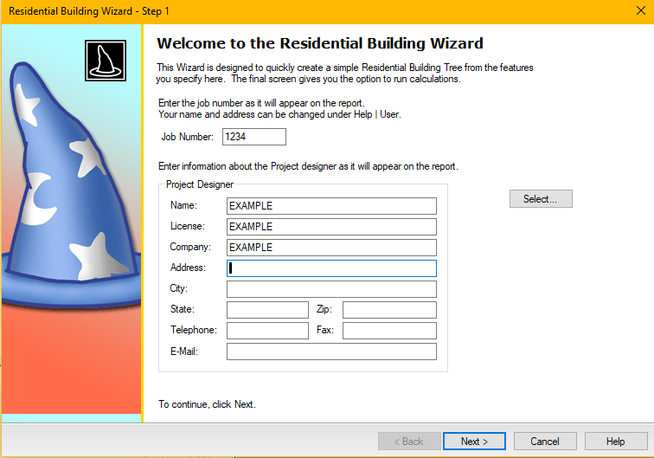

- Project Information. For the Prescriptive Method, it is important to fill out the Location of your Project located in the red square below. Make sure you input as much information as you can so accurate calculations can be performed. We will input San Diego, California – Zone 7.
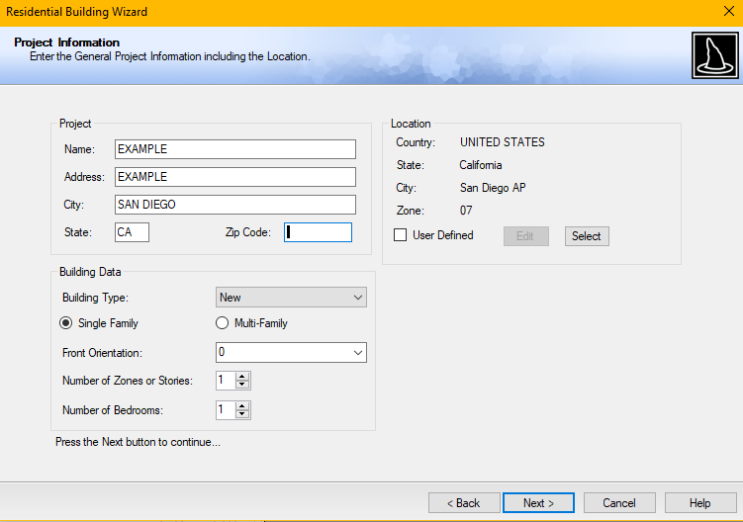

- Select Construction Details. By clicking on the magnifying glass, you can choose from a variety of building system selections. For our case we will keep all standard choices for all systems but Wall Construction, where we will select an 8” CMU Wall.
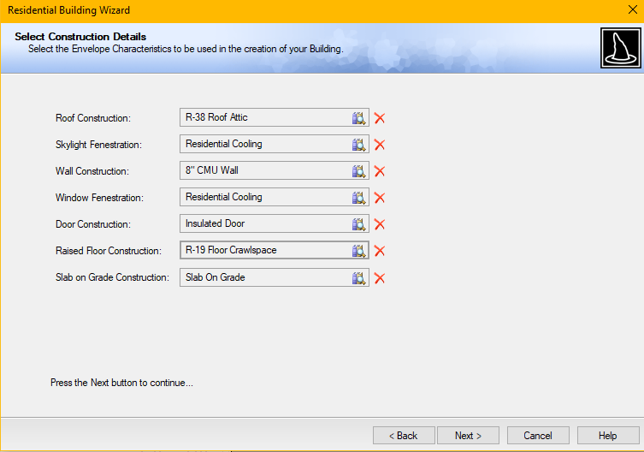
- Zone 1 Envelope. We will input the dimensions of our building. We will go with a 20’x20’ with an 8-foot wall. The calculations of the space will automatically calculate based on your inputs in the grayed-out section under “Gross Opaque”. In the “Misc.” section in the bottom left, we have the building type as “New”, roof slope set to 4/12, and one floor. We will change the building type in a later section to comply with the prescriptive code.
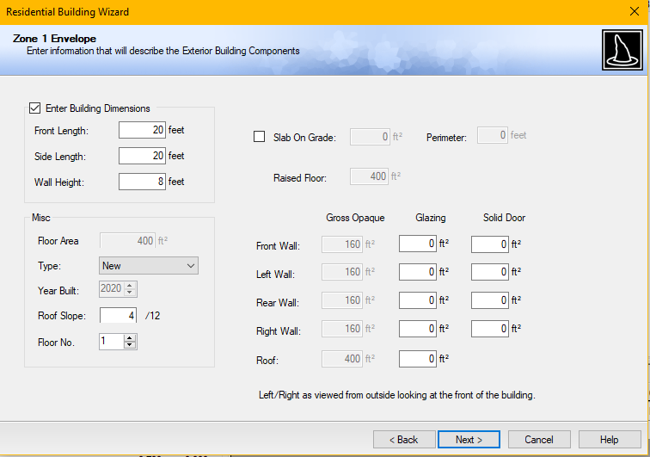
- Select Mechanical Details. For this section, we will select the “Standard Gas Tankless” and keep all the other information that was already in here. We can always go back and change settings later if the system does not comply.
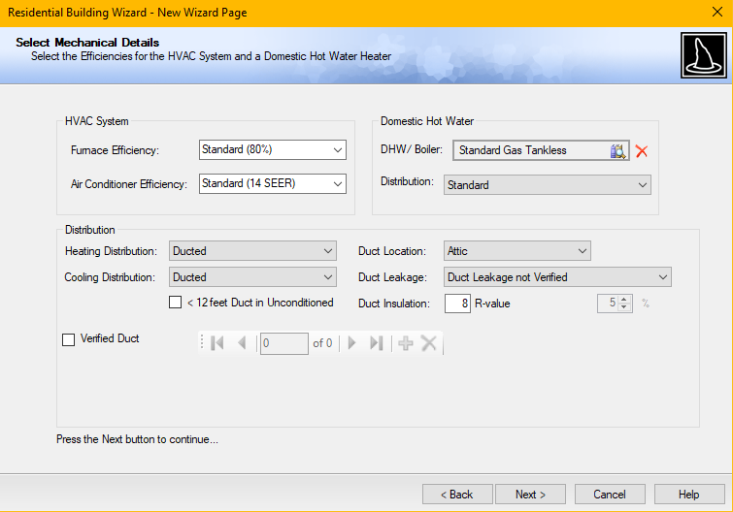
- Building Complete. We will not check in boxes in this section because we will choose different calculations in later steps.
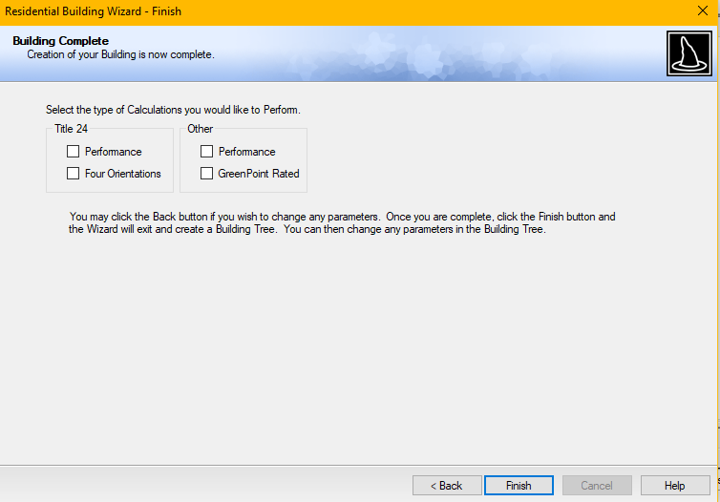

- Calculate. Based on the information we have inputted in the initial design, we will test it to see if it complies. For this we will select “Calculate” in the Task Bar and then select “Residential Title 24 Prescriptive”.
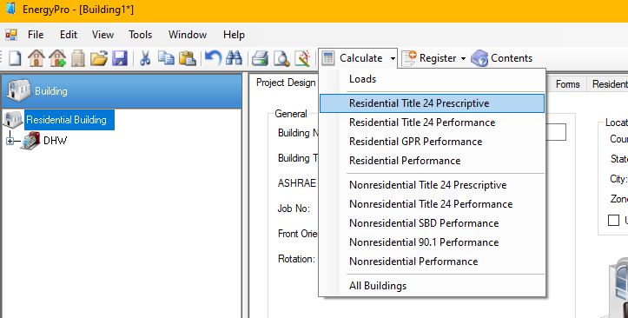
- Error. This error shows that there is additional information we must add before the program can run our calculation. In the bottom section of your screen, you will find the Error Issue and the Solution to your error. If you do not understand the solution or error, you can click the hyperlink to learn more about the error.
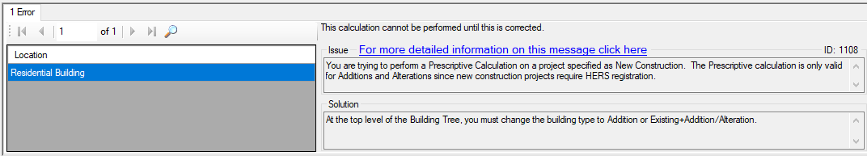
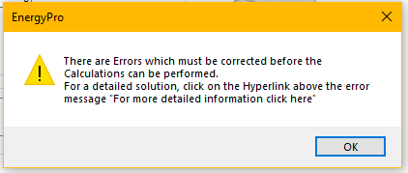

- Fix Error. The issue in performing a Prescriptive Calculation on the building we have currently designed is that it cannot preform a calculation on new construction. Therefore, we must go into the Building Tree and change the building type to “Addition” or “Existing+Addition/Alteration.” We will change it to “Existing+Addition/Alteration.”
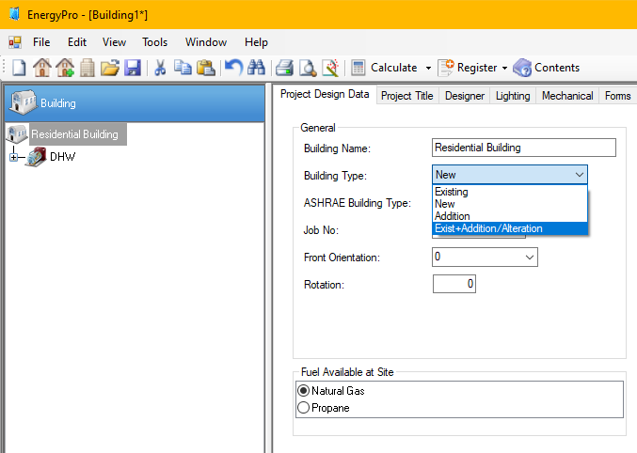
- Calculate Again. Select “Calculate” following the same procedure as Step 9. At the bottom of the screen it has a section for “Compliance” and tells you whether your building complies or not. Our states “Does Not Comply.” Therefore, we will then select the “Warnings” tab to see what needs to be changed in order to comply with the Residential Title 24 Prescriptive method.
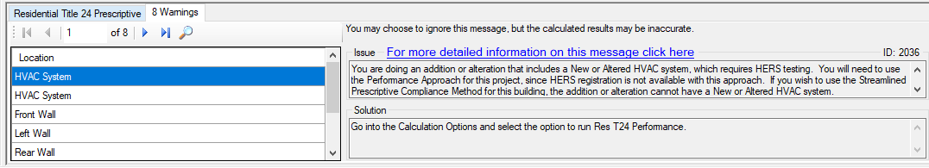
- Fix Errors. Follow the Solution for each “location” of error.
  - HVAC System: “You are doing an addition or alteration that includes a New or Altered HVAC duct system, which requires HERS testing. You will need to use the Performance Approach for this project, since HERS registration is not available with this approach. If you wish to use the Streamlined Prescriptive Compliance Method for this building, the addition or alteration cannot have a New or Altered HVAC duct system.”
Solution: “Go into the Calculation Options and select the option to run Res T24 Performance.” In this case we will NOT follow the solution suggested by EnergyPro8. Because we want a Prescriptive Compliance Method, we will simply change the System Type for the HVAC System to “Existing”.
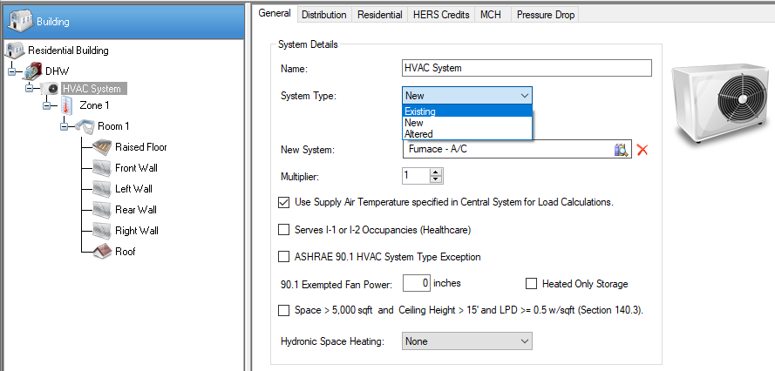
  - HVAC System: “You are doing an addition or alteration that includes a New or Altered HVAC duct system, which requires HERS testing. You will need to use the Performance Approach for this project, since HERS registration is not available with this approach. If you wish to use the Streamlined Prescriptive Compliance Method for this building, the addition or alteration cannot have a New or Altered HVAC duct system.”
Solution: “Go into the Calculation Options and select the option to run Res T24 Performance.” Because we want a Prescriptive Compliance Method, we will simply change the System Type for the Distribution Duct System to “Existing”.
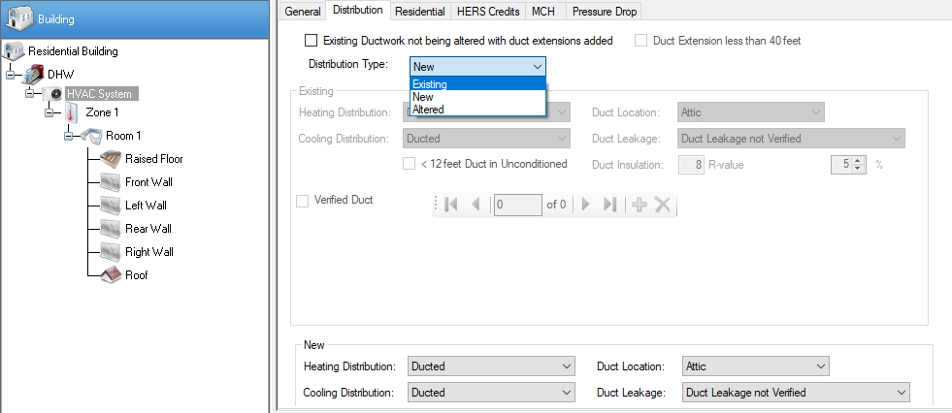
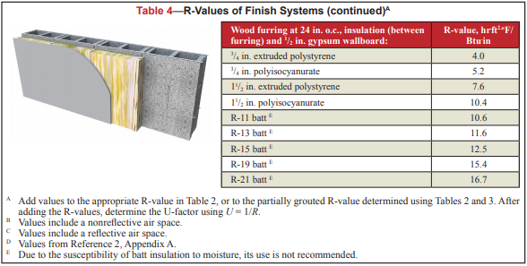
  - Front Wall: “The component Front Wall has a U-Factor of 0.690, which exceeds the maximum allowed U-Factor. If you wish to use the Prescriptive Envelope Compliance Method for this building, the insulation level on this component must be increased.”
Solution: “Go into the Assembly Library and edit this assembly to increase the insulation level so the U-Factor does not exceed a value of 0.065, or show compliance with the Performance Approach.” Look for resources outside of EnergyPro8 to find what insulation would work. We used TEK Note 06-02C for R-values and U-factors of Single Wythe Concrete Masonry Walls. The table below from the Tek Note gave many options for wood insulation that would give a large enough R-value to comply our wall with the Prescriptive Method.

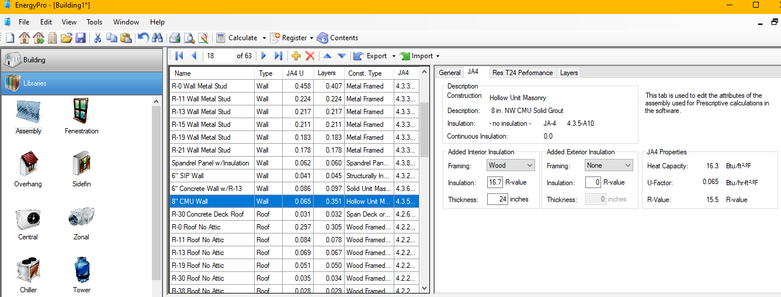

- Recalculate. Following the procedure in Step 9, recalculate to see if the building complies. In some instances, a fix to one error will be a solution to others as well. Look below to see if the building complies, and it does.
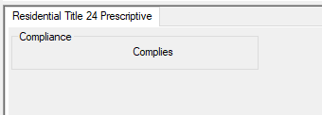

- Check with 2019 California Energy Code: Prescriptive Method.
  - NCMA TEK NOTE: 06-16A, Table 3 provides Heat Capacities of 8-in. CMU Concrete Masonry Walls. For the example above, an 8-in CMU wall with a density of 115 lb/ft3 was selected. In the table for a hollow unit, no vertical grout spacing, and full mortar bedding, the heat capacity of the wall is 7.0 Btu/ft2-F. Therefore, this wall is classified as Mass Light. (For a detailed example on how to classify and design a Mass Light wall, see section ##.)
  - Table 140.3-B in the 2019 California Energy Code outlines the Max U-factor based on climate zone. The climate zone selected for this example is 7. Therefore, the associated Max U-factor is labeled as 0.440.
  - The Max U-factor outlined in EnergyPro was 0.065. While the original design with a U-factor of 0.690 would not work, EnergyPro software produced conservative results. The amount of insulation provided under EnergyPro guidelines will work but is conservative for application as outlined by the Prescriptive Method found in the 2019 California Energy Code.

