Example of Energy Pro8 use for the design a small mix use nonresidential building. This is based on one of the ENERGYPRO* example and changes the exterior walls to masonry using the performance method. Note that this is a single story building with office space, retail space, a restaurant and a garage.
The basic building information must be inputted into the go through the following process
- START: OPENING SCREEN

- CLICK “FILE” AND FIND THE THREE BUILDING WIZARDS ENTITLED “Residential Building Wizard”, “ “Nonresidential Building Wizard”. Select the “NonResidential Building Wizard”.

- Input the project information using the wizard See the Prescriptive example. Note that much of the building information is available through drop down menus and loadable libraries . This facilitates filling information that you may not have during this Phase of the design by allowing reasonable guesses on systems to be made. The tutoring example will lead you through the specific system inputs (see the ENGY PRO8 Help – Non residential Sample Building Tutorial)

- Once your Input is complete you should get a screen like that shown below the shows a complete “Building tree” on the left column.

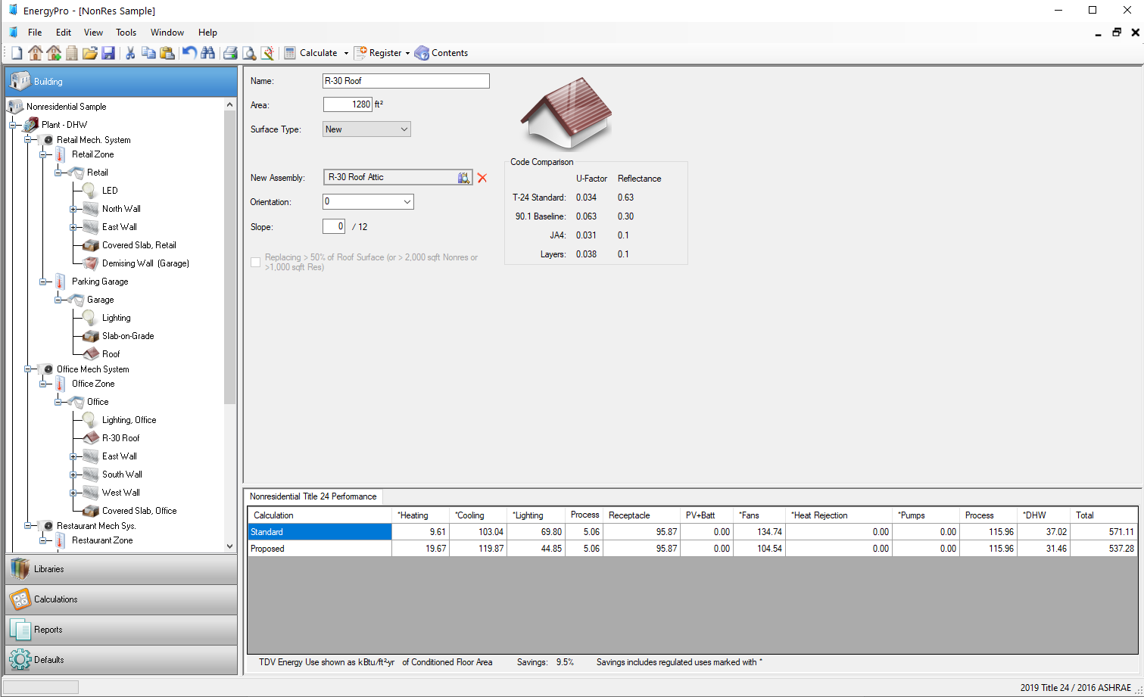
Note that each element may have a + sign that can be click to expand the areas in the building tree. Note there are four areas in this building, Office, restaurant, Retail and Garage.

- To run EnergyPro8 on this building Performance Compliance. Click on Nonresidential Title 24 Performance .
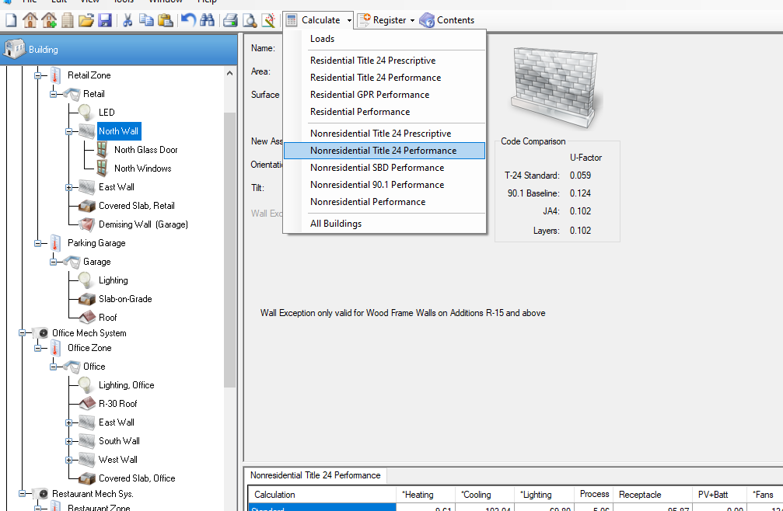
- EnergyPro8 will go through a number of calculations on this building energy use and return a TVD for both the proposed building and the same building but with just the prescriptive and mandatory code provisions incorporated into it (Standard). As long as the TDV of the proposed building is less than or equal to the standard then the proposed design is in compliance. Note only HVAC, lighting and domestic hot water are regulated.

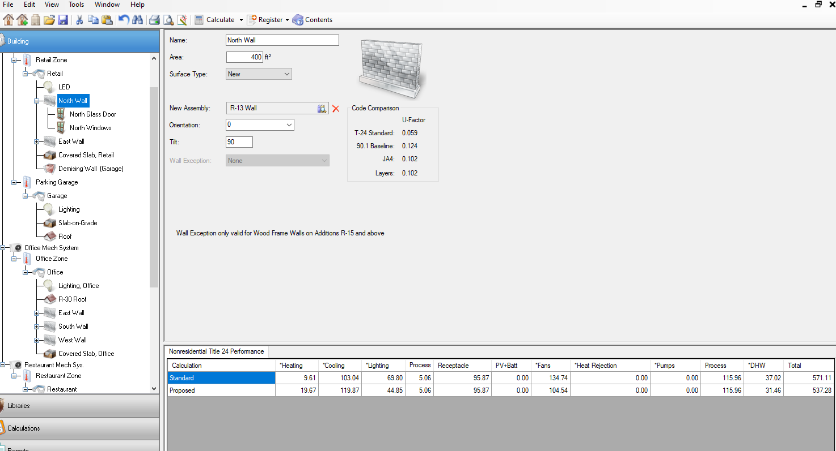
- The example building uses exterior stud walls and bat insulation on the exterior. To illustrate how the use of exterior masonry walls can be used for this building . First click on each wall in each area then change the wall systems for each wall type as shown.
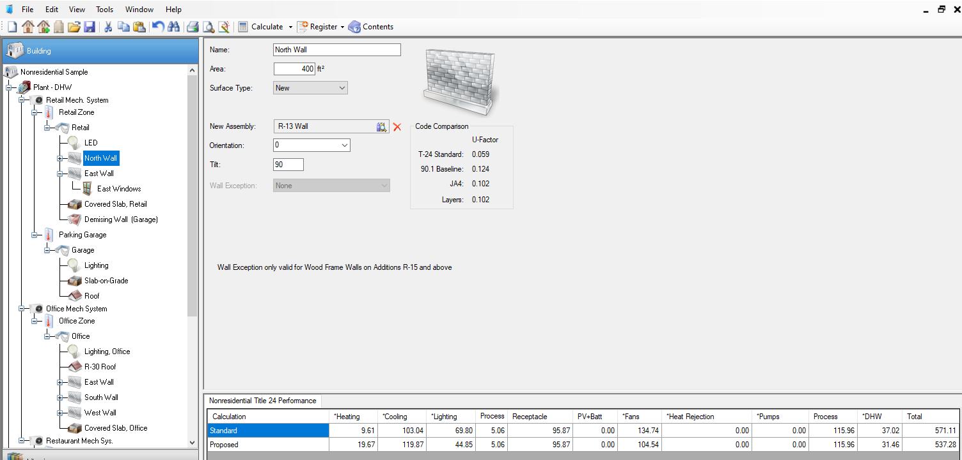
- Click on New Assembly and a library of wall types come up. If the wall type is not there, click on import.

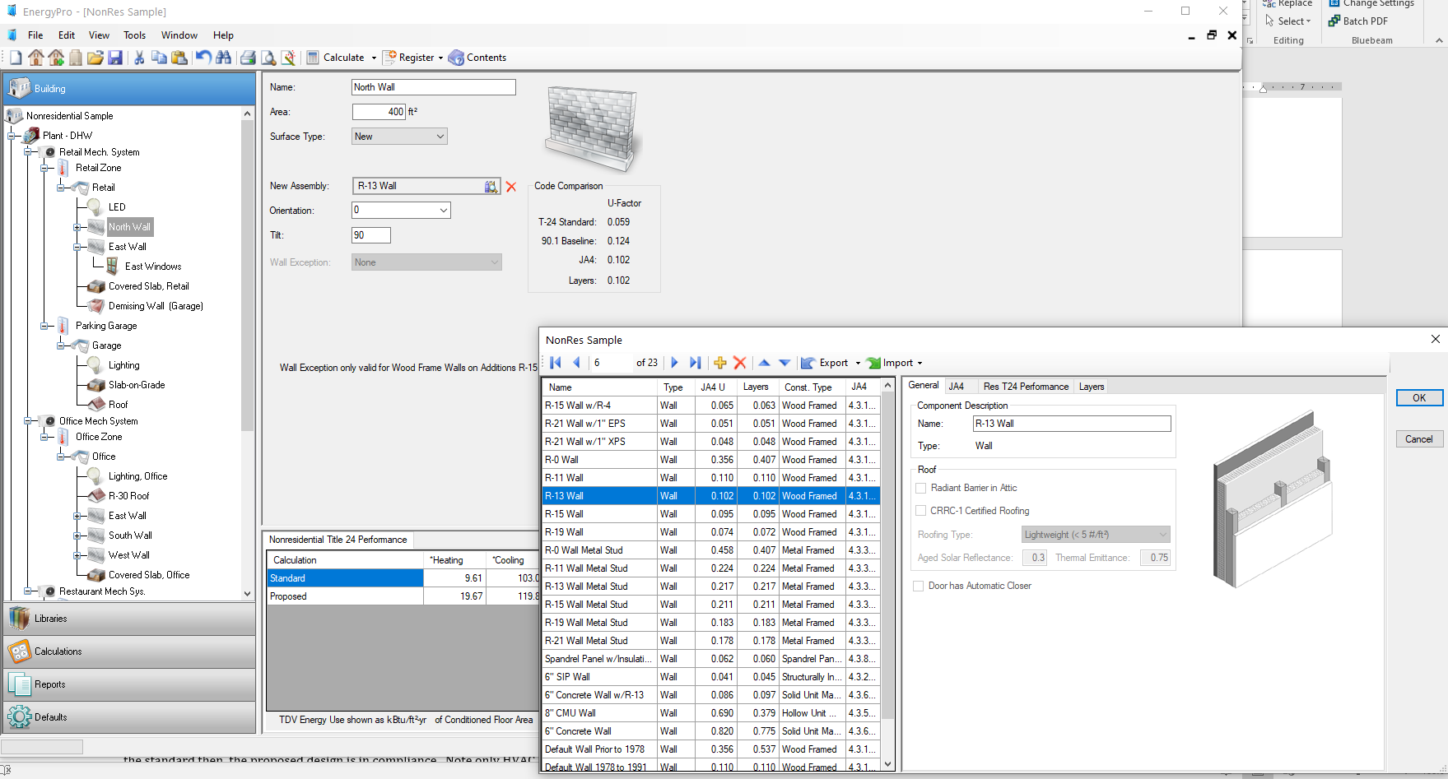

- Click on New Assembly and a library of wall types come up. If the wall type is not there , click on import. Select the wall type you want. Move to Solid Masonry walls 8 inch and select this and click OK. Note this U-factor matches the U-factor in the NCAM Thermal Catalogue for solid masonry for about 100 psf density with no insulation. Note that you can adjust the U-factor by editing the information in the layers tab. See U-factor analysis examples.

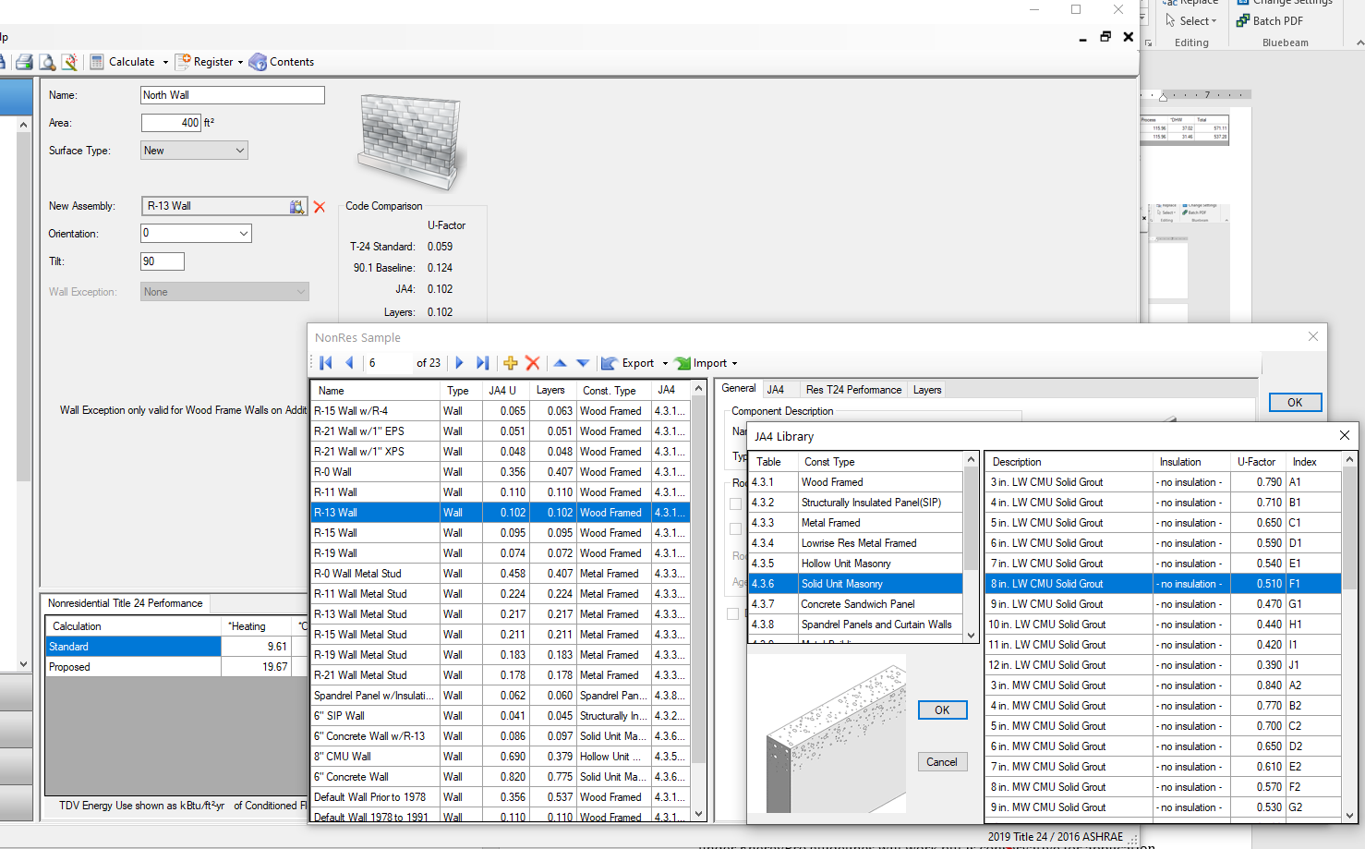
- Repeat this process for each exterior wall in each of the areas. There is a way to change all walls at the same time. Please see the Energypro8 manual.

- When you have all walls in each of the areas changed go back to the main window and analyze the system again (step 5).

- The window below will come up again. Note that the savings is now a negative and the total TVD of the Proposed system is greater than the Standard configuration.
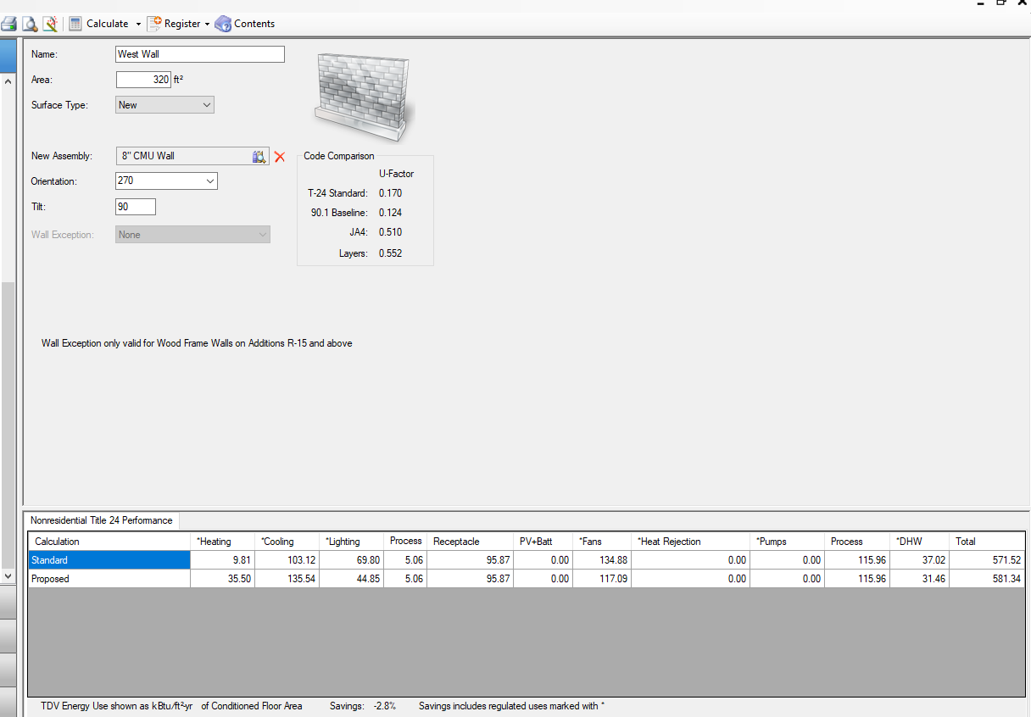

- To get energy Code compliance look at changing energy consuming systems to conduct the trade-offs. In this example, I went to the lighting system first (drop down menues as shown) but found the light system already uses LED lights. I then went to the Domestic hot water system and chose a more efficient system (use the drop down menus and Click OK to accept changes). I then changed the roof system from an R 30 to R 38 Roof then to an R 30 concrete deck (to illustrate the impact of thermal mass). I reran the analysis each time.
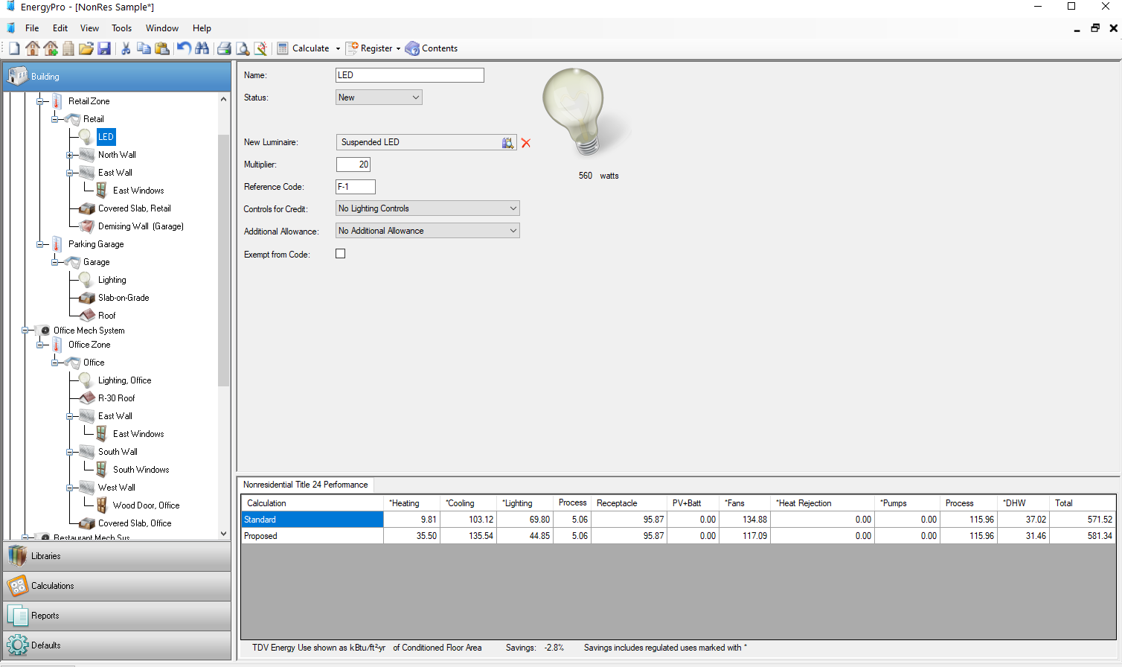

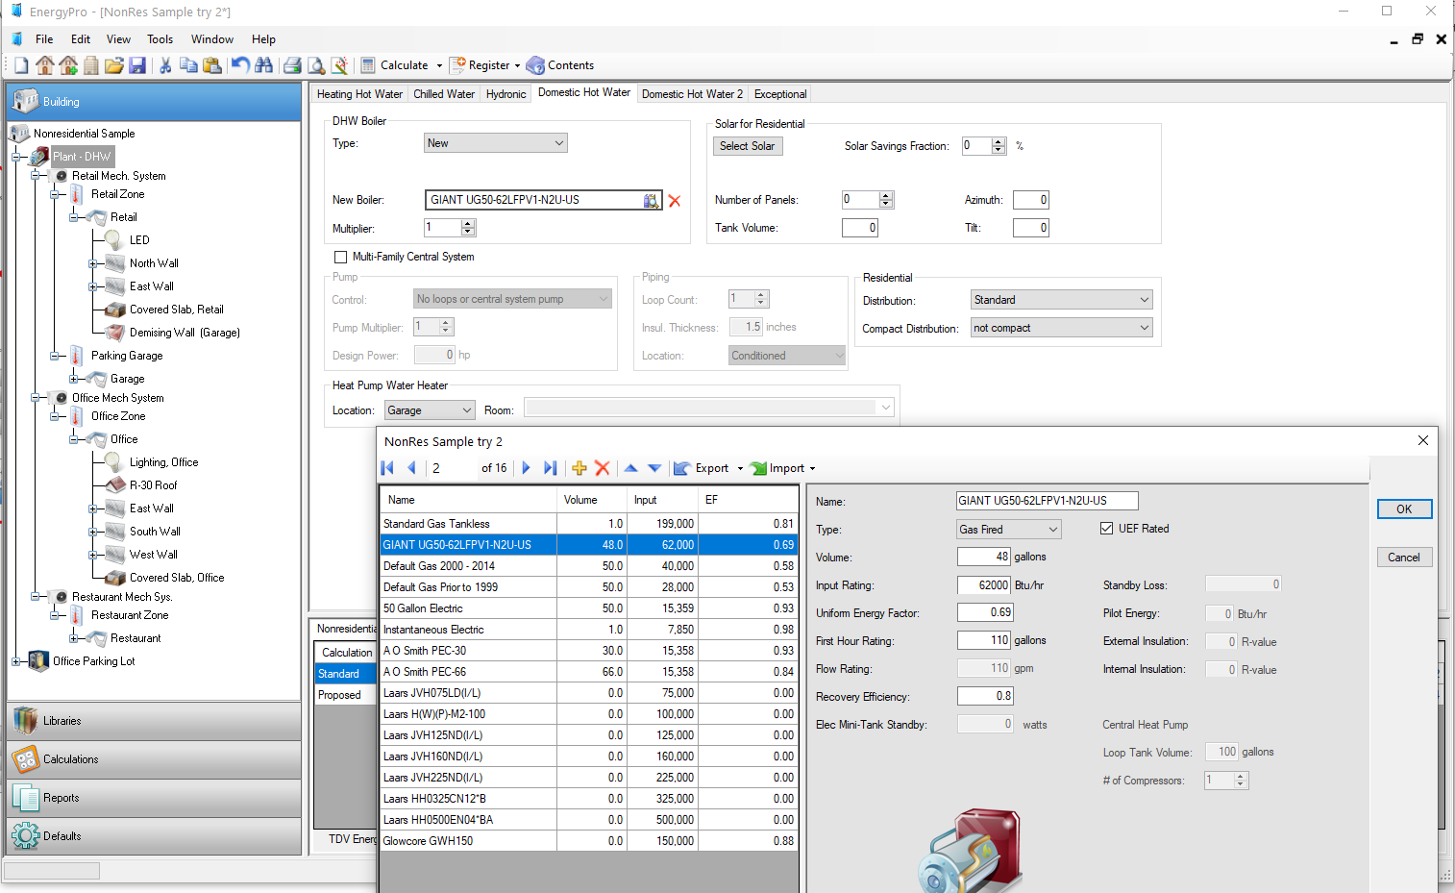

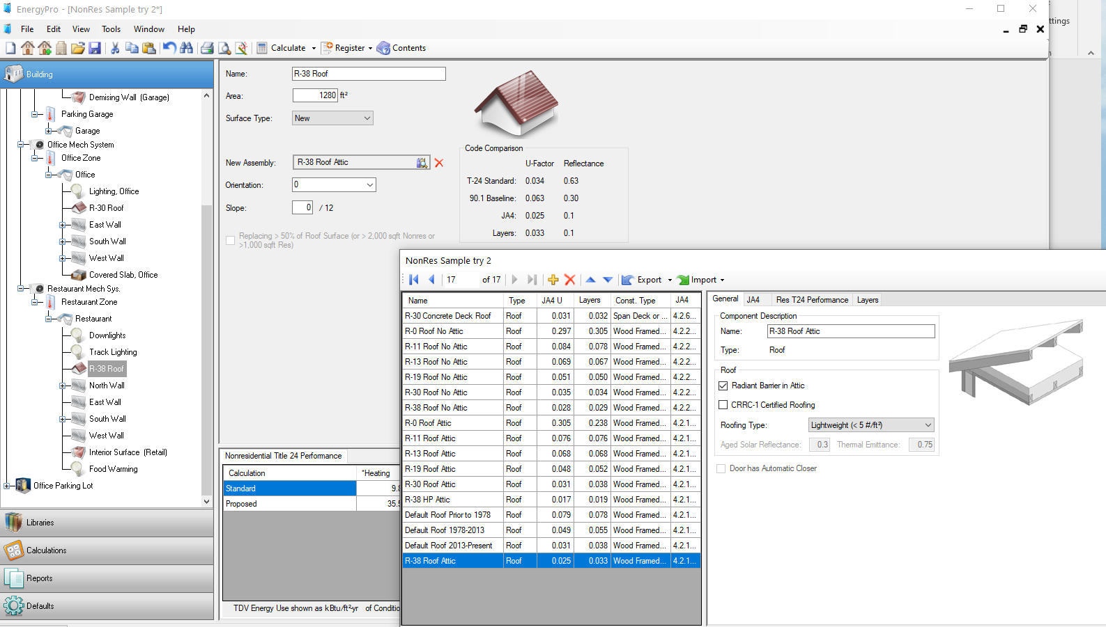
- The end results of this analysis is shown below. Note that the savings shows a positive value of 0.1% and the systems are compliant.
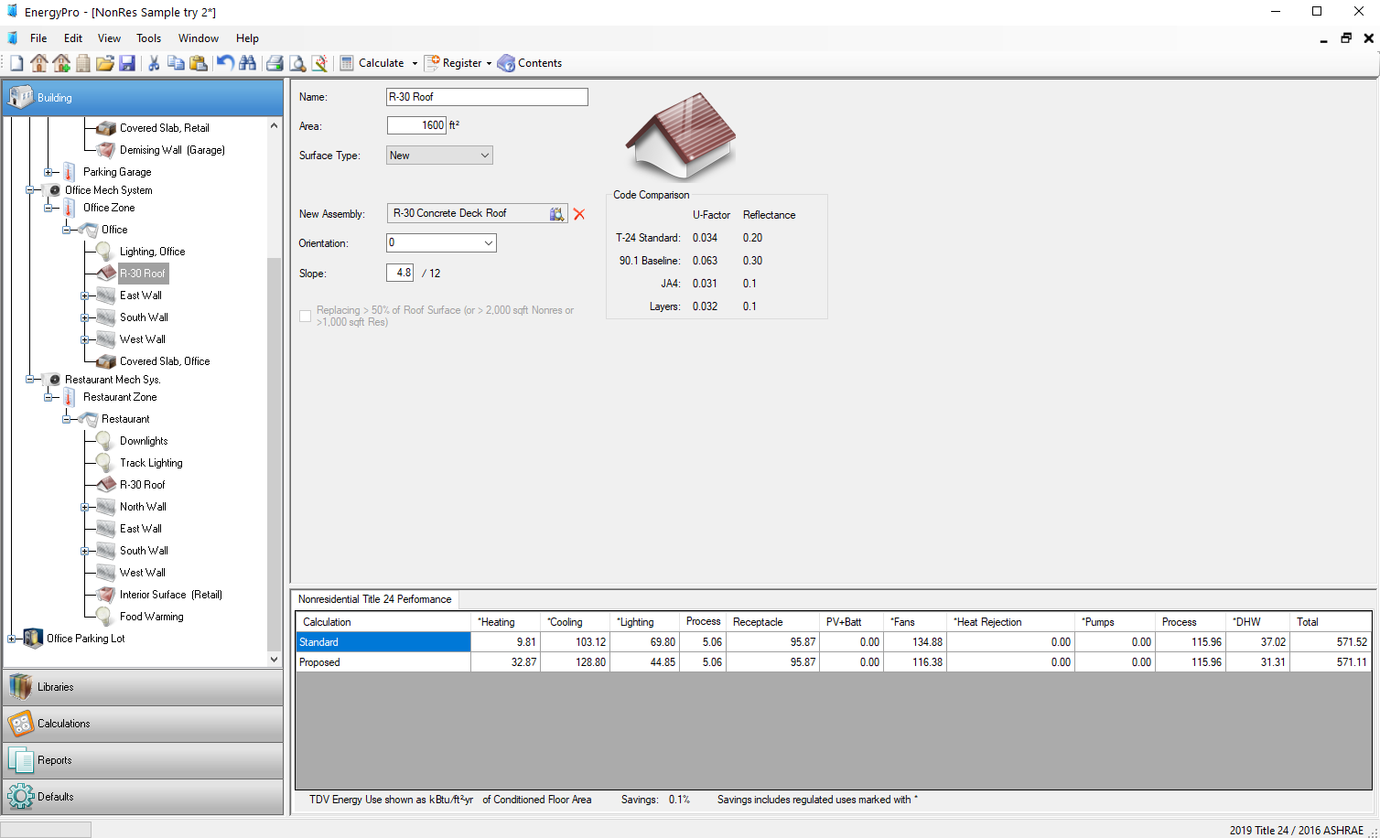

In general, this program can be run to look at trade-offs between envelope systems if you do not know much about the HVAC system (+domestic hot water) or lighting, between the envelope systems and lighting if not much is known about the HVAC system (+ domestic hot water) and between all three systems if enough information about these systems are known. In general, changing U values in the envelope system (anywhere near reasonably low U-factor values) not as effective as changing lighting, HVAC, or domestic hot water systems (and are usually more cost effective).

