CALIFORNIA ENERGY CODE 2019
OVERVIEW
Table of Contents:
SUBCHAPTER 1: ALL OCCUPANCIES – GENERAL PROVISIONS
SUBCHAPTER 2: ALL OCCUPANCIES – MANDATORY REQUIREMENTS FOR THE MANUFACTURE, CONSTRUCTION AND INSTALLATION OF SYSTEMS, EQUIPMENT AND BUILDING COMPONENTS
SUBCHAPTER 3: NONRESIDENTIAL, HIGH-RISE RESIDENTIAL HOTEL/MOTEL OCCUPANCIES, AND COVERED PROCESSES – MANDATORY REQUIREMENTS
SUBCHAPTER 4: NONRESIDENTIAL, HIGH-RISE RESIDENTIAL AND HOTEL/MOTEL OCCUPANCIES – MANDATORY REQUIREMENTS FOR LIGHTING SYSTEMS AND EQUIPMENT, AND ELECTRICAL POWER DISTRIBUTION SYSTEMS
SUBCHAPTER 5: NONRESIDENTIAL, HIGH-RISE RESIDENTIAL AND HOTEL/MOTEL OCCUPANCIES – PREFORMANCE AND PRESCRIPTIVE COMPLIANCE APPROACHES FOR ACHIEVING ENERGY EFFICIENCY
SUBCHAPTER 6: NONRESIDENTIAL, HIGH-RISE RESIDENTIAL AND HOTEL/MOTEL OCCUPANCIES – ADDITIONS, ALTERATIONS AND REPAIRS
SUBCHAPTER 7: LOW-RISE RESIDENTIAL BUILDINGS – MANDATORY FEATURES AND DEVICES
SUBCHAPTER 8: LOW-RISE RESIDENTIAL BUILDINGS – PERFORMANCE AND PRESCRIPTIVE COMPLIANCE APPROACHES
SUBCHAPTER 9: LOW-RISE RESIDENTIAL BUILDINGS – ADDITIONS AND ALTERATIONS TO EXISTING LOW-RISE RESIDENTIAL BUILDINGS

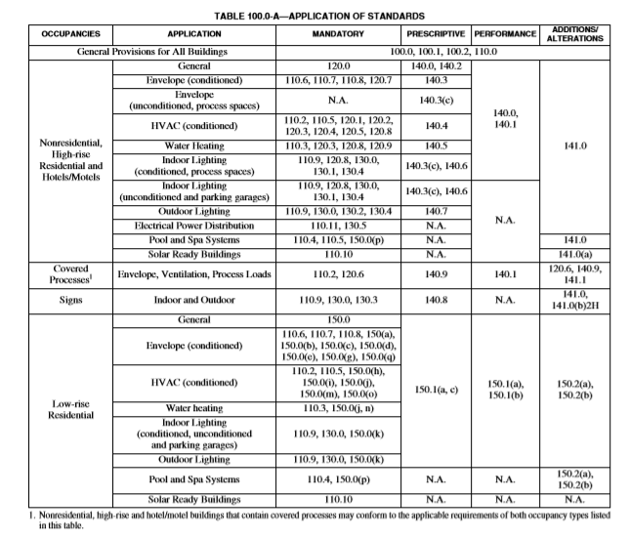
GENERAL PROVISIONS

CODE COMPLIANCE STANDARDS: APPROACHES
SUBCHAPTER 1 - SECTION 100.0 SCOPE
B. Nonresidential, high-rise residential and hotel/motel buildings that are mechanically hearted or mechanically cooled
ii. Compliance approaches. In order to comply with Part 6, newly constructed nonresidential buildings, high-rise residential buildings and hotels/motels that are mechanically heated or mechanically cooled must meet the requirements of:
a. Mandatory measures: The applicable provisions of Sections 120.0 through 130.5; and
b. Either:
(i) Performance approach: Section 140.1
SUBCHAPTER 5 – SECTION 140.1 PERFORMANCE APPROACH: ENERGY BUDGETS
A building complies with the performance approach if the energy budget calculated for the proposed design building under Subsection (b) is no greater than the energy budget calculated for the standard design building under Subsection (a).
(a) Energy budget for the standard design building. The energy budget for the Standard Design Building is determined by applying the mandatory and prescriptive requirements to the proposed design building. The energy budget is the sum of the TDV energy for space-conditioning, indoor lighting, mechanical ventilation, service water heating and covered process loads.
(b) Energy budget for the proposed design building. The energy budget for a proposed design building is determined by calculating the TDV energy for the proposed design building. The energy budget is the sum of the TDV energy for space-conditioning, indoor lighting, mechanical ventilation and service water heating and covered process loads.
(c) Calculation of energy budget. The TDV energy for both the standard design building and the proposed design building shall be computed by compliance software certified for this use by the Commission. The processes for compliance software approval by the Commission are documented in the ACM Approval Manual.

(ii) Prescriptive approach: Sections 140.2 through 140.8
SUBCHAPTER 5 – SECTION 140.2 PRESCRIPTIVE APPROACH
To comply using the prescriptive approach a building shall be designed with and shall have constructed and installed systems and components meeting the applicable requirements of Sections 140.3 through 140.9.
SUBCHAPTER 5 – SECTION 140.3 PRESCRIPTIVE REQUIREMENTS FOR BUILDING ENVELOPES
A building complies with this section by being designed with and having constructed to meet all prescriptive requirements in Subsection (a) and the requirements of Subsection (c) and (d) where they apply.
(a) Envelope component requirements.
1. Exterior roofs and ceilings. Exterior roofs and ceilings shall comply with each of the applicable requirements in this subsection:
A. Roofing products. Shall meet the requirements of Section 110.8 and the applicable requirements of Subsections i through ii:
i. Nonresidential buildings:
a. Low-sloped roofs in climate zones 1 through 16 shall have:
1. A minimum aged solar reflectance of 0.63 and a minimum thermal emittance of 0.75; or
2. A minimum solar reflectance index (SRI) of 75.
Exception 1 to Section 140.3(a)1Aia: Wood framed roofs in climate zones 3 and 5 are exempt from the requirements of Section 140.3(a)1Aia if the roof assembly has a U-factor of 0.034 or lower.
Exception2 to Section 140.3(a)1Aia: Roof constructions with a weight of at least 25 lb/ft2 over the roof membrane are exempt from the requirements of Section 140.3(a)1Aia.
Exception 3 to Section 140.3(a)1Aia: An aged solar reflectance less than 0.63 is allowed provided the maximum roof/ceiling U-factor in Table 140.3 is not exceeded.
b. Steep-sloped roofs in climate zones 1 through 16 shall have a minimum aged solar reflectance of 0.20 and a minimum thermal emittance of 0.75, or a minimum SRI of 16.
ii. High-rise residential buildings and hotels and motels:
- Low-sloped roofs in Climate Zones 9, 10, 11, 13, 14 and 15 shall have a minimum aged solar reflectance of 0.55 and a minimum thermal emittance of 0.75, or a minimum SRI of 64.

Exception to Section 140.3(a)1Aiia: Roof constructions with a weight of at least 25 lb/ft2 over the roof membrane.

- Steep-sloped roofs in climate zones 2 through 15 shall have a minimum aged solar reflectance of 0.20 and a minimum thermal emittance of 0.75, or a minimum SRI of 16.
Exception to Section 140.3(a)1A: Roof area covered by building integrated photovoltaic panels and building integrated solar thermal panels are not required to meet the minimum requirements for solar reflectance, thermal emittance, or SRI.
B. Roof insulation. Roofs shall have an overall assembly U-factor no greater than the applicable value in Table 140.3-B, C or D, and where required by Section 110.8 and 120.7(a)3, insulation shall be placed in direct contact with a continuous roof or drywall ceiling.
2. Exterior walls. Exterior walls shall have an overall assembly U-factor no greater than the applicable value in Table 140.3-B, C or D.
3. Demising walls. Demising walls shall meet the requirements of Section 120.7(b)7. Vertical windows in demising walls between conditioned and unconditioned spaces shall have an area-weighted average U-factor no greater than the applicable value in Table 140.3-B, C or D.
4. Exterior floors and soffits. Exterior floors and soffits shall have an overall assembly U-factor no greater than the applicable value in Table 140.3-B, C or D.
5. Exterior Windows. Vertical windows in exterior walls shall:
A. Percent window area shall be limited in accordance with the applicable requirements of i and ii below:
i. a west-facing area no greater than 40 percent of the gross west-facing exterior wall area, or 6 feet times the west-facing display perimeter, whichever is greater;
ii. a total area no greater than 40 percent of the gross exterior wall area, or 6 feet times the display perimeter, whichever is greater; and
NOTE: Demising walls are not exterior walls, and therefore demising wall area is not part of the gross exterior wall area or display perimeter and windows in demising walls are not part of the window area.
B. Have an area-weighted average U-factor no greater than the applicable value in Table 140.3-B, C or D.
Exception to Section 140.3(a)5B: For vertical windows containing chromogenic type glazing:
- The lower-rated labeled U-factor shall be used with automatic controls to modulate the amount of heat flow into the space in multiple steps in response to daylight levels or solar intensity; and
- Chromogenic glazing shall be considered separately from other glazing; and
- Area-weighted averaging with other glazing that is not chromogenic shall not be permitted.
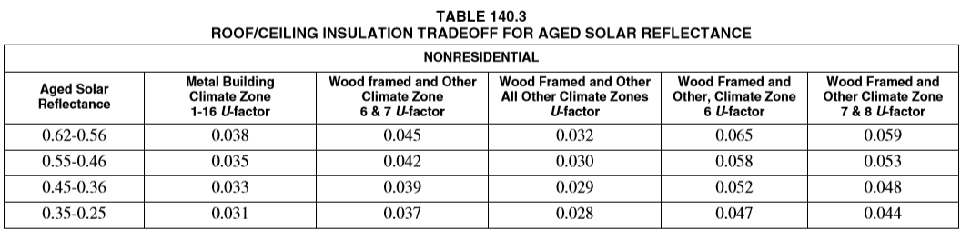
C. Have an area-weighted average relative solar heat gain coefficient, RSHGC, excluding the effects of interior shading, no greater than the applicable value in Table 140.3-B, C or D.
For purposes of this paragraph, the relative solar heat gain coefficient, RSHGC, of a vertical window is:
- The solar heat gain coefficient of the windows; or
- Relative solar heat gain coefficient is calculated using Equation 140.3-A, if the window has an overhang that extends beyond each side of the window jamb by a distance equal to the overhang’s horizontal projection.
Exception 1 to Section 143(a)5C: An area weighted average relative solar heat gain coefficient of 0.56 or less shall be used for windows:
  - That are in the first story of exterior walls that form a display perimeter; and
  - For which codes restrict the use of overhangs to shade the windows.
Exception 2 to Section 140.3(a)5C: For vertical glazing containing chromogenic type glazing:
- the lower-rate labeled RSHGC shall be used with automatic controls to modulate the amount of heat flow into the space in multiple steps in response to daylight levels or solar intensity to demonstrate compliance with this section; and
- chromogenic glazing shall be considered separately from other glazing; and
- area-weighted averaging with other glazing that is not chromogenic shall not be permitted. NOTE: Demising walls are not exterior walls, and therefore windows in demising walls are not subject to SHGC requirements.
D. Have an area-weighted average visible transmittance (VT), no less than the applicable value in Tables 140.33-B and C, or Equation 140.3-B, as applicable.
Exception 1 to Section 140.3(a)5D: When the window’s primary and secondary sidelit daylit zones are completely overlapped by one or more skylit daylit zones, then the window need not comply with Section 140.3(a)5D.
Exception 2 to Section 140.3(a)5D: If the window’s VT is not within the scope of NFRC 200, or ASTM E972, then the VT shall be calculated according to Reference Nonresidential Appendix NA6.
Exception 3 to Section 140.3(a)5D: For vertical windows containing chromogenic type glazing:
- The higher-rate labeled VT shall be used with automatic controls to modulate the amount of light transmitted into the space in multiple steps in response to daylight levels or solar intensity; and
- Chromogenic glazing shall be considered separately from other glazing; and
- Area-weighted averaging with other glazing that is not chromogenic shall not be permitted.
NOTE: Demising walls are not exterior walls, and therefore windows in demising walls are not subject to VT requirements.

SECTION 140.3-140.4 SUMMARAIZED TABLES AND EQUATIONS
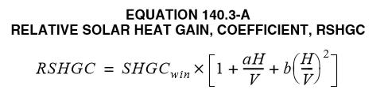
where:
RSHGC = Relative Solar Heat Gain Coefficient.
SHGC_{win} = Solar Heat Gain Coefficient of the window.
H = horizontal projection of the overhang from the surface of the window in feet, but no greater than V.
V = vertical distance from the windowsill to the bottom of the overhang, in feet.
a = -0.41 for north-facing windows, -1.22 for south-facing windows and -0.92 for east and west-facing windows.
b = 0.20 for north-facing windows, 0.66 for south-facing windows and 0.35 for east and west-facing windows.
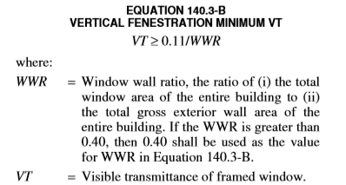
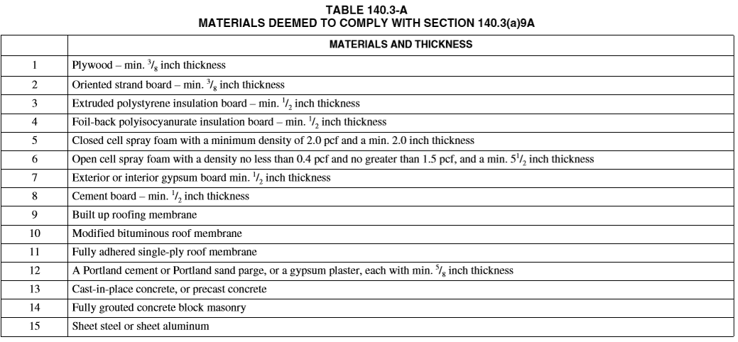
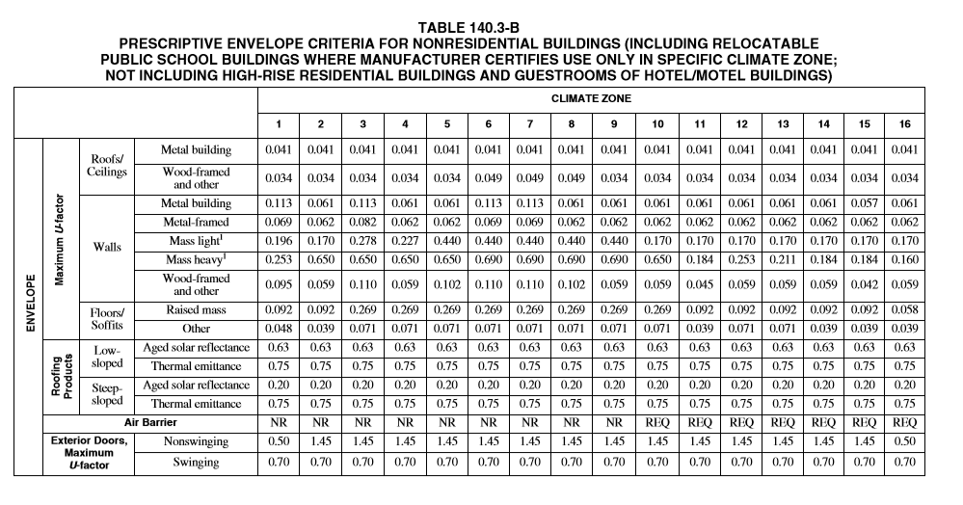
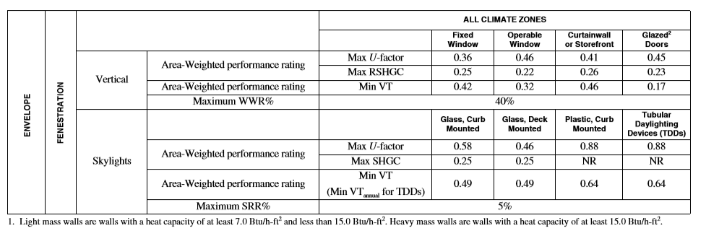
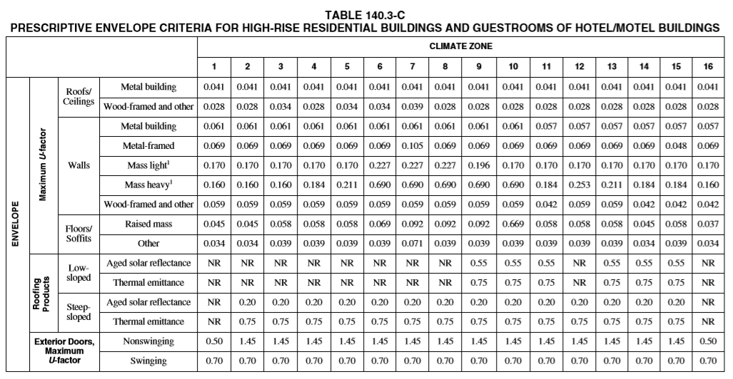
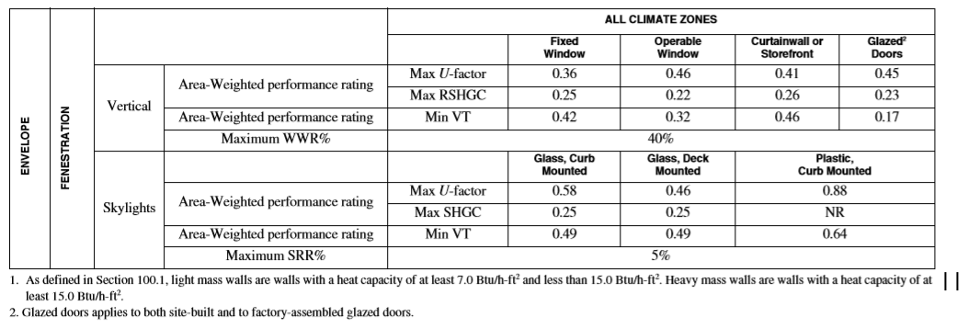
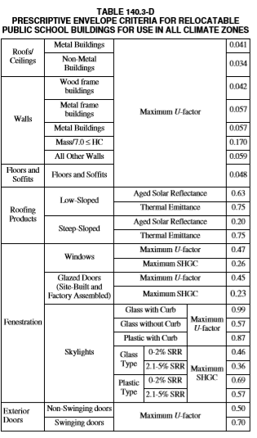
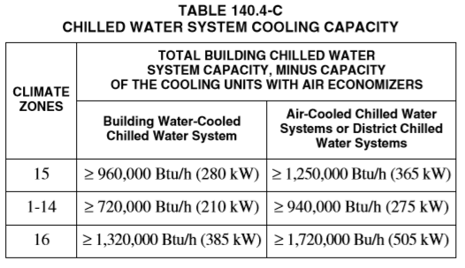

SECTION 140.5 PRESCRIPTIVE REQUIREMENTS FOR SERVICE WATER-HEATING SYSTEMS
(a) Nonresidential occupancies. A service water-heating system installed in a nonresidential building complies with this section if it complies with the applicable requirements of Sections 110.1, 110.3 and 120.3.
(b) High-rise residential and hotel/motel occupancies. A service water-heating system installed in high-rise residential or hotel/motel buildings complies with this section if it meets the requirements of Section 150.1(c)8.

SUBCHAPTER 2 – SECTION 110.6 Mandatory Requirements for Fenestration Products and Exterior Doors
6. Fenestration acceptance requirements. Before an occupancy permit is granted site-built fenestration products in other than low-rise residential buildings shall be certified as meeting the Acceptance Requirements for Code Compliance, as specified in the Reference Nonresidential Appendix NA7 to ensure that site built fenestration meets Standards requirements, including a matching label certificate for product(s) installed and be readily accessible at the project location. A certificate of acceptance certifying that the fenestration product meets the acceptance requirements shall be completed, signed and submitted to the enforcement agency.
Exception to Section 110.6(a): Fenestration products removed and reinstalled as part of a building alteration or addition.
(b) Installation of field-fabricated fenestration and exterior doors. Field-fabricated fenestration and field-fabricated exterior doors may be installed only if the compliance documentation has demonstrated compliance for the installation using U-factors from Table 110.6-A and SHGC values from Table 110.6-B. Field-fabricated fenestration and field fabricated exterior doors shall be caulked between the fenestration products or exterior door and the building, and shall be weather stripped.
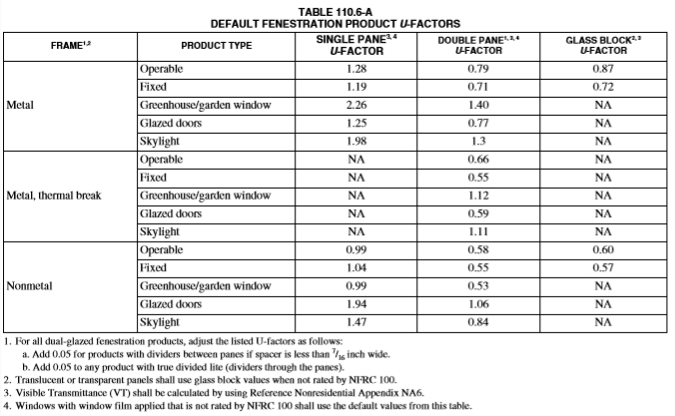

SUBCHAPTER 2
SUBCHAPTER 2 – 110.2 Mandatory Requirements for Space Conditioning Equipment
(a) Efficiency. Equipment shall meet the applicable efficiency requirements in Tables 110.2-A through 110.2-K, subject to the following:
1. If more than one efficiency standard is listed for any equipment in Tables 110.2-A through 110.2-K, the equipment shall meet all the applicable standards that are listed; and
2. If more than one test method is listed in Tables 110.2-A through 110.2-K, the equipment shall comply with the applicable efficiency standard when tested with each listed test method; and
3. Where equipment serves more than one function, it shall comply with the efficiency standards applicable to each function; and
4. Where a requirement is for equipment rated at its “maximum rated capacity” or “minimum rated capacity,” the capacity shall be as provided for and allowed by the controls, during steady-state operation.
Exception 1 to Section 110.2(a): Water-cooled centrifugal water-chilling packages that are not designed for operation at ANSI/AHRI Standard 550/ 590 test conditions of 44°F leaving chilled water temperature and 85°F entering condenser water temperature with 3 gallons per minute per ton condenser water flow shall have a maximum full load kW/ton and NPLV ratings adjusted using the following equation:
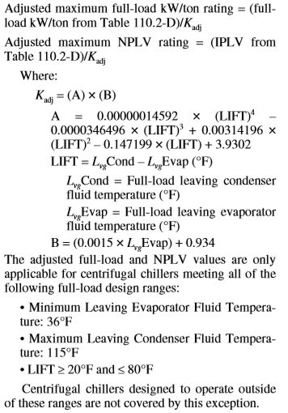
The adjusted full-load and NPLV values are only applicable for centrifugal chillers meeting all of the following full-load design ranges:
      - Minimum Leaving Evaporator Fluid Temperature: 36°F
      - Maximum Leaving Condenser Fluid Temperature: 115°F
      - LIFT ≥ 20°F and ≤ 80°F Centrifugal chillers designed to operate outside of these ranges are not covered by this exception.
Exception 2 to Section 110.2(a): Positive displacement (air-cooled and water-cooled) chillers with a leaving evaporator fluid temperature higher than 32°F shall show compliance with Table 110.2-D when tested or certified with water at standard rating conditions, per the referenced test procedure.
Exception 3 to Section 110.2(a): Equipment primarily serving refrigerated warehouses or commercial refrigeration.
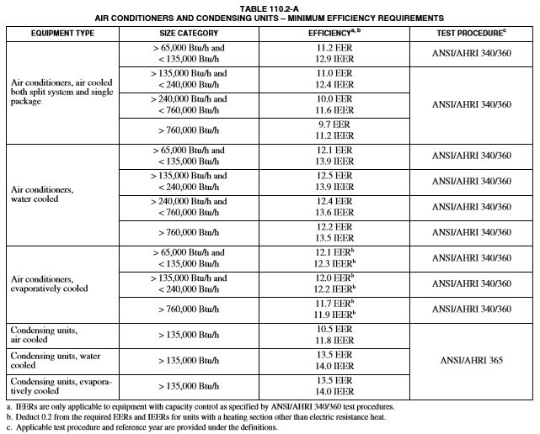

SUBCHAPTER 2 – 110.6 Mandatory Requirements for Fenestration Products and Exterior Doors
(a) Certification of fenestration products and exterior doors other than field fabricated. Any fenestration product and exterior door, other than field-fabricated fenestration products and field-fabricated exterior doors, may be installed only if the manufacturer has certified to the Commission, or if an independent certifying organization approved by the Commission has certified, that the product complies with all of the applicable requirements of this subsection.
1. Air leakage. Manufactured fenestration products and exterior doors shall have air infiltration rates not exceeding 0.3 cfm/ft2 of window area, 0.3 cfm/ft2 of door area for residential doors, 0.3 cfm/ft2 of door area for nonresidential single doors (swinging and sliding), and 1.0 cfm/ft2 for nonresidential double doors (swinging), when tested according to NFRC-400 or ASTM E283 at a pressure differential of 75 pascals (or 1.57 pounds/ft2), incorporated herein by reference.
2. U-factor. The fenestration product and exterior door’s U-factor shall be rated in accordance with NFRC 100, or use the applicable default U-factor set forth in Table 110.6-A.
3. Solar heat gain coefficient SHGC. The fenestration product’s SHGC shall be rated in accordance with NFRC 200, or use the applicable default SHGC set forth in Table 110.6-B.
4. Visible transmittance (VT). The fenestration product’s VT shall be rated in accordance with NFRC 200 or ASTM E972. For tubular daylighting devices VT shall be rated using NFRC 203.
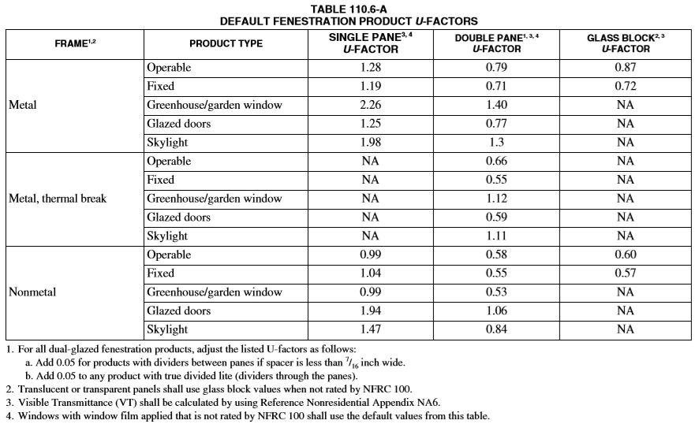
SUBCHAPTER 2 – 110.7 Mandatory Requirements to Limit Air Leakage
All joints, penetrations and other openings in the building envelope that are potential sources of air leakage shall be caulked, gasketed, weather-stripped or otherwise sealed to limit infiltration and exfiltration.
SUBCHAPTER 2 – 110.8 Mandatory Requirements for Insulation, Roofing Products and Radiant Barriers

SUBCHAPTER 2 – 110.12 Mandatory Requirements for Demand Management:
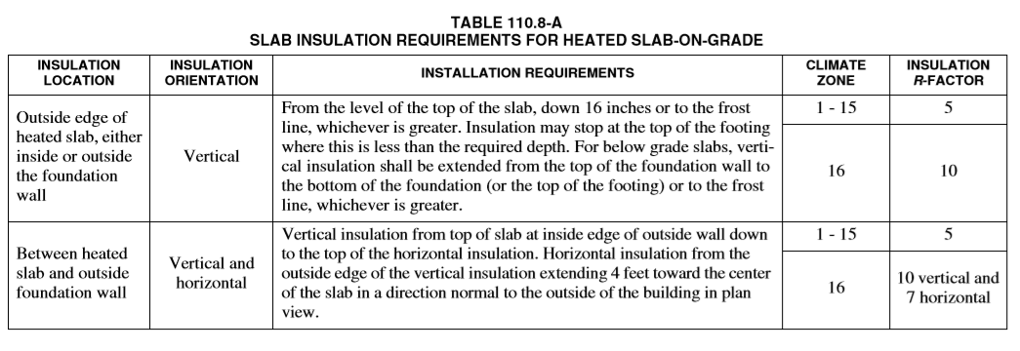
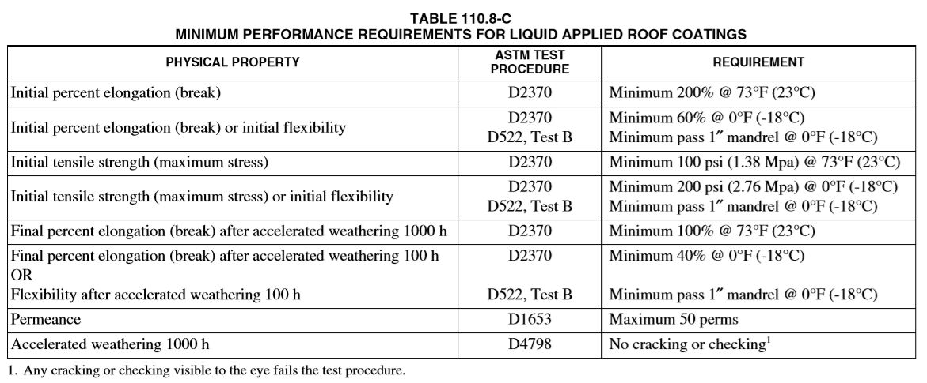

SUBCHAPTER 3
SUBCHAPTER 3 - 120.1 Requirements for Ventilation and Indoor Air Quality
(b) High-rise residential buildings.
1. Air filtration.
A. System types specified in subsections i, ii, and iii shall be provided with air filters in accordance with Sections 120.1(b)1B through 1D. System types specified in subsection i shall also comply with Section 120.1(b)1E.
i. Mechanical space conditioning systems that supply air to an occupiable space through ductwork exceeding 10 feet (3 m) in length.
ii. Mechanical supply-only ventilation systems that provide outside air to an occupiable space.
iii. The supply side of mechanical balanced ventilation systems, including heat recovery ventilation systems and energy recovery ventilation systems that provide outside air to an occupiable space.
B. System design and installation.
i. The system shall be designed to ensure that all recirculated air or outdoor air supplied to the occupiable space is filtered before passing through any system thermal conditioning components.
ii. All systems shall be designed to accommodate the clean-filter pressure drop imposed by the system air filter(s). The design airflow rate, and maximum allowable clean filter pressure drop at the design airflow rate applicable to each air filter shall be determined and reported on labels according to subsection iv below.
iii. All system air filters shall be located and installed in such a manner as to be accessible for regular service by the system owner.
iv. All system air filter installation locations shall be labeled to disclose the applicable design airflow rate and the maximum allowable clean-filter pressure drop. The labels shall be permanently affixed to the air filter installation location, readily legible, and visible to a person replacing the air filter.
C. Air filter efficiency. The system shall be provided with air filter(s) having a designated efficiency equal to or greater than MERV 13 when tested in accordance with ASHRAE Standard 52.2, or a particle size efficiency rating equal to or greater than 50 percent in the 0.30–1.0 µm range and equal to or greater than 85 percent in the 1.0–3.0 µm range, when tested in accordance with AHRI Standard 680.
D. Air filter pressure drop. All systems shall be provided with air filter(s) that conform to the applicable maximum allowable clean-filter pressure drop specified by i, ii or iii below, when tested using ASHRAE Standard 52.2, or as rated using AHRI Standard 680, for the applicable design airflow rate(s) for the system air filter(s).
2. Attached dwelling units. All dwelling units shall meet the requirements of ASHRAE Standard 62.2, Ventilation and Acceptable Indoor Air Quality in Residential Buildings, subject to the amendments specified in subsection A below. All dwelling units shall comply with the acceptance requirements specified in subsection B below.
A. Amendments to ASHRAE 62.2 requirements.
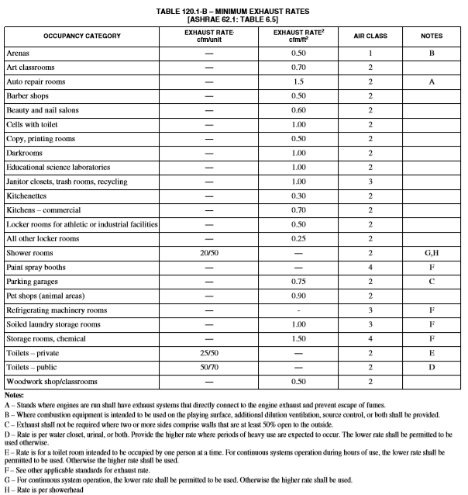

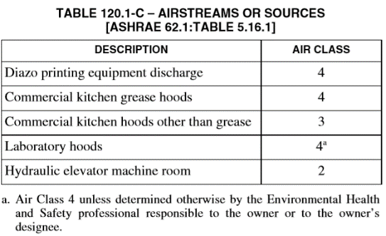

SUBCHAPTER 3 – 120.7 Mandatory Insulation
Nonresidential, high-rise residential, and hotel/motel buildings shall comply with the applicable requirements in Sections 120.7(a) through 120.7(c).
(a) Roof/Ceiling insulation. The opaque portions of the roof/ceiling that separates conditioned spaces from unconditioned spaces or ambient air shall meet the applicable requirements of Items 1 through 3 below:
1. Metal building. The weighted average U-factor of the roof assembly shall not exceed 0.098.
2. Wood framed and others. The weighted average Ufactor of the roof assembly shall not exceed 0.075.
3. Insulation placement. Insulation installed to limit heat loss and gain from conditioned spaces to unconditioned spaces.
(b) Wall insulation. The opaque portions of walls that separate conditioned spaces from unconditioned spaces or ambient air shall meet the applicable requirements of Items 1 through 7 below:
1. Metal building. The weighted average U-factor of the wall assembly shall not exceed 0.113.
2. Metal framed. The weighted average U-factor of the wall assembly shall not exceed 0.151.
3. Light mass walls. A 6-inch or greater hollow core concrete masonry unit shall have a U-factor not to exceed 0.440.
4. Heavy mass walls. An 8-inch or greater hollow core concrete masonry unit shall have a U-factor not to exceed 0.690.
5. Wood framed and others. The weighted average Ufactor of the wall assembly shall not exceed 0.110.
6. Spandrel panels and curtain wall. The weighted average U-factor of the spandrel panels and curtain wall assembly shall not exceed 0.280.
7. Demising walls. The opaque portions of framed demising walls shall meet the requirements of Item A or B below:
A. Wood framed walls shall be insulated to meet a U-factor not greater than 0.099.
B. Metal framed walls shall be insulated to meet a U-factor not greater than 0.151.
(c) Floor and soffit insulation. The opaque portions of floors and soffits that separate conditioned spaces from unconditioned spaces or ambient air shall meet the applicable requirements of Items 1 and 2 below:
1. Raised mass floors. Shall have a minimum of 3 inches of lightweight concrete over a metal deck, or the weighted average U-factor of the floor assembly shall not exceed 0.269.
2. Other floors. The weighted average U-factor of the floor assembly shall not exceed 0.071.
3. Heated slab on grade floor. A heated slab on grade floor shall be insulated to meet the requirements of Section 110.8(g).

