Prescriptive CMU Wall Design Examples and Select Prescriptive Code Section Discussion
In the following section, a brief over view of select prescriptive provisions of the California Energy Code with presented and discussed. In addition, an exterior 8-inch CMU wall will be designed using these prescriptive Energy Code provisions. Various exterior masonry wall configurations that comply with the prescriptive provisions of the Energy Code for Climate Zone 8 and Climate Zone 16 will be presented.
A 12-inch CMU wall. Wall assembly example is also presented. It was assumed that these walls are part of a small retail space.

General Code Provisions
The 2019 California Energy Code: Title 24 Part 6 is the code employed by the California Building Standards Commission. There are two basic compliance approached in the 2019 California Energy Code; the Performance Method and the Prescriptive Method. The following examples follow the Prescriptive Method from Subchapter 5: Sections 140.3 – 140.9 of the 2019 California Energy Code.
Below is an excerpt from Section 140.3 Prescriptive Requirements for Building Envelopes outlining the Prescriptive requirements for Exterior Walls.
“Exterior walls. Exterior walls shall have an overall assembly U-factor no greater than the applicable value in Table 140.3-B, C or D.”
Table 140.3-B represents the Prescriptive Envelope Criteria for Nonresidential Buildings (including relocatable public-school buildings where manufacturer certifies use only in specific climate zones; not including high-rise residential buildings and guestrooms of hotel/motel buildings). Table 140.3-C represents Prescriptive Envelope Criteria for High-Rise Residential Buildings and Guestrooms of Hotel/Motel Buildings. Table 140.3-D represents Prescriptive Envelope Criteria for Relocatable Public-School Buildings for use in all Climate Zones. The following example will utilize Table 140.3-B in the example design.
Below is an excerpt from Section 140.3 Prescriptive Requirements for Building Envelopes outlining the Prescriptive requirements for Fenestration (doors and windows).
“Exterior doors. All exterior doors that separate conditioned space from unconditioned space or from ambient air shall have a U-factor not greater than the applicable value in Table 140.3-B, C or D. Doors that are more than one-half glass in area are considered glazed doors.”
“Exterior Windows. Vertical windows in exterior walls shall:
A. Percent window area shall be limited in accordance with the applicable requirements of i and ii below:
i. a west-facing area no greater than 40 percent of the gross west-facing exterior wall area, or 6 feet times the west-facing display perimeter, whichever is greater.
ii. a total area no greater than 40 percent of the gross exterior wall area, or 6 feet times the display perimeter, whichever is greater; and
B. Have an area-weighted average U-factor no greater than the applicable value in Table 140.3-B, C or D.
C. Have an area-weighted average relative solar heat gain coefficient, RSHGC, excluding the effects of interior shading, no greater than the applicable value in Table 140.3-B, C or D.
D. Have an area-weighted average visible transmittance (VT), no less than the applicable value in Tables 140.33-B and C, or Equation 140.3-B, as applicable.
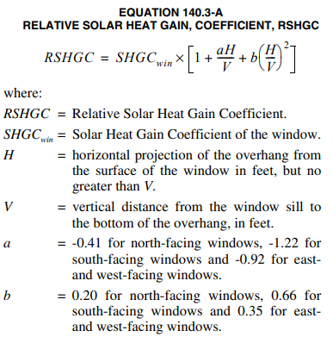
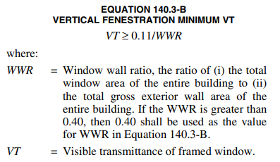”
Below is an excerpt from Section 140.3 Prescriptive Requirements for Building Envelopes . This section outlines the Prescriptive requirements for Roofing Products.
“A. Roofing products. Shall meet the requirements of Section 110.8 and the applicable requirements of Subsections i through ii:
i. Nonresidential buildings:
a. Low-sloped roofs in climate zones 1 through 16 shall have:
1. A minimum aged solar reflectance of 0.63 and a minimum thermal emittance of 0.75; or
2. A minimum solar reflectance index (SRI) of 75.
Exception2 to Section 140.3(a)1Aia: Roof constructions with a weight of at least 25 lb/ft2 over the roof membrane are exempt from the requirements of Section 140.3(a)1Aia.
Exception 3 to Section 140.3(a)1Aia: An aged solar reflectance less than 0.63 is allowed provided the maximum roof/ceiling U-factor in Table 140.3 is not exceeded.”
Opaque walls are required to have assembly U-factors limited as described in the code. For this example, Table 140.3-B (from the energy code) must be used to determine the maximum U-factors allowed for exterior masonry walls in Climate Zones 8 and 16. Note that U factors for Walls, and Fenestration are also listed as shown in the following tables.
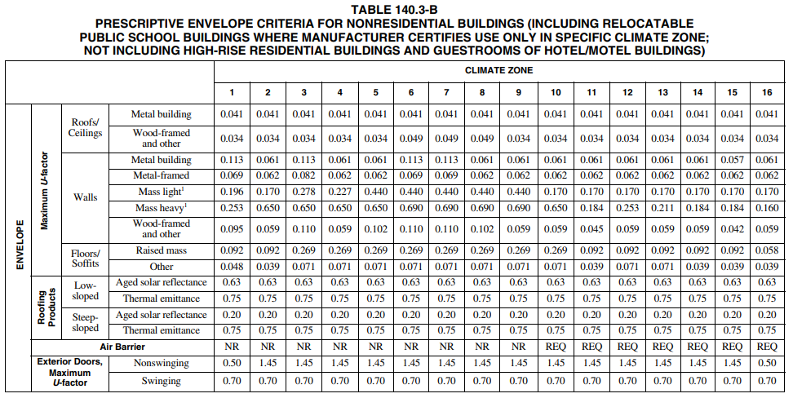

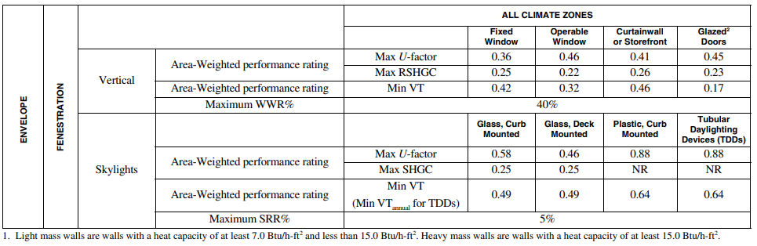
The footnote at the bottom of the table states, “Light Mass walls are walls with a heat capacity of at least 7.0 Btu/h-ft² and less than 15.0 Btu/h-ft². Heavy mass walls are walls with a heat capacity (HC) that is greater than 15.0 Btu/h-ft².” For exterior masonry walls the heat capacity of the wall assembly must be first determined to identify the correct limiting U-Factor. These heat capacities can be found using the design aids in NCMA TEK NOTE: 06-16A Heat Capacity (HC) Values for Concrete Masonry Walls, with Table 3 applying to 8-in CMU walls and Table 5 applying to 12-inch CMU walls.
When designing exterior masonry walls using the prescriptive procedures one must first determine whether the wall is a light mass wall or a heavy mass wall. Published masonry wall HC tables can be used to determine this classification. Note that wall HC is dependent on the heat capacity and density of the units, the vertical grout spacing, and mortar bedding. There are typically a number wall and unit configurations that may meet each classification.
Once the wall systems are classified, maximum U-factors can be determined for a specific building use. Design guides like the NCMA Thermal Catalog of Concrete Masonry Assemblies: Second Edition can then be used to configure wall assemblies to meet the maximum U-factor requirements.
Example #1: Table 3 (from the NCMA TEK NOTE: 06-16A) shows five (highlighted in red) acceptable exterior CMU wall configurations that that can be classified as a Mass Light 8-inch fully grouted CMU wall for Climate Zone 8. (that is they have a heat capacity of at least 7.0 Btu/h-ft² and less than 15.0 Btu/h-ft²). Note that there are more than five wall configurations that classify the wall as Mass Light.
For a hollow, no grout wall configuration, the unit density must be at least 125 lb/ft³ for face shell mortar bedding and at least 115 lb/ft³ for a full mortar bedding to be classified as a mass light wall. A hollow, face shell bedded wall is the lightest unit that be classified as a mass light wall with a unit density equal to 85 lb/ft³ but it would need to be grouted at least at 40 inches on center. In comparison, all 8-inch fully grouted wall configuration would have heat capacities greater than 15.0 Btu/ft²-F and thus be classified as a mass heavy wall.
Example #1 The following wall configurations and their properties were classified as a mass light wall.

Mass Light Wall Configurations found from Table 3
 | Unit | Vertical Grout Spacing | Mortar  Bedding | Minimum Density | Heat Capacity
Wall Configuration 1 | Hollow | No grout | Face shell | 125 lb/ft³ | 7.5 Btu/ft²-F
Wall Configuration 2 | Hollow | No grout | Full | 115 lb/ft³ | 7.0 Btu/ft²-F
Wall Configuration 3 | Hollow | 16 inches | Face shell | 85 lb/ft³ | 10.2 Btu/ft²-F
Wall Configuration 4 | Hollow | 24 inches | Face shell | 85 lb/ft³ | 8.5 Btu/ft²-F
Wall Configuration 5 | Hollow | 32 inches | Face shell | 85 lb/ft³ | 7.7 Btu/ft²-F
For a mass light exterior wall, Table 140.3 B would require maximum wall U-factors of 0.440 for Climate Zone 8.
It was assumed that hollow 8 in CMU walls (Configuration 1) with foam insulation in all the ungrouted cores are to be used (The most cost effective and durable configuration). See Assembly 1-1 below (From: NCMA.org- Thermal Catalog of Concrete Masonry Assemblies: Second Edition).
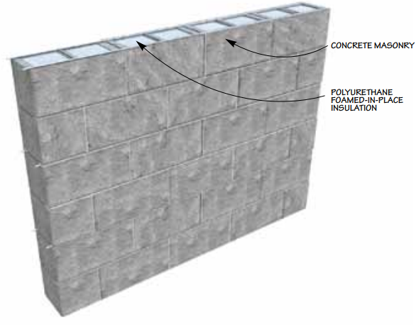
Assembly 1-1
Assembly 1-1 Details
The following details of Assembly 1-1 is an excerpt from the Thermal Catalog of Concrete Masonry Assemblies: Second Edition.
“Assembly 1-1: Polyurethane foamed-in-place insulation in ungrouted cells, exposed masonry (interior and exterior):
- Masonry exposed on both the interior and exterior provides maximum durability.
- Values in table assume no insulation in grouted cells. Note that some rigid inserts are configured to accommodate insulation, reinforcing steel and grout in the same cell, which can improve R-values.
- Other masonry cell insulations include molded polystyrene inserts, other types of foamed-in-place insulations and expanded perlite or vermiculite granular fills. These insulations will have different thermal properties than polyurethane which will affect the resulting R-value.
- Cell insulation, in contrast to additional insulation on either side of the wall, allows some of the thermal mass (masonry) to be in direct contact with the indoor air, providing excellent thermal mass benefits. Insulation should occupy all ungrouted cells.
- “Lightly reinforced” = grout 8 ft o.c. both vertically and horizontally (or vertical reinforcement only at 48 in. o.c.). “Heavily reinforced” = grout 32 in o.c. vertically and 48 in. o.c. horizontally (or vertical reinforcement only at 24 in. o.c.).”

A chart (shown below) from the Thermal Catalog of Concrete Masonry Assemblies: Second Edition shows acceptable designs, outlined in yellow, for a mass light 8-inch CMU Wall. The maximum U-factor in the 2019 California Energy Code for a mass light wall for Climate Zone 8 is equal to 0.440. The U –factors for either an 8-inch Ungrouted, Lightly Reinforced, or Heavily Reinforced walls for any density (in brackets) are shown to be below this maximum values and are acceptable based on the prescriptive code requirements.
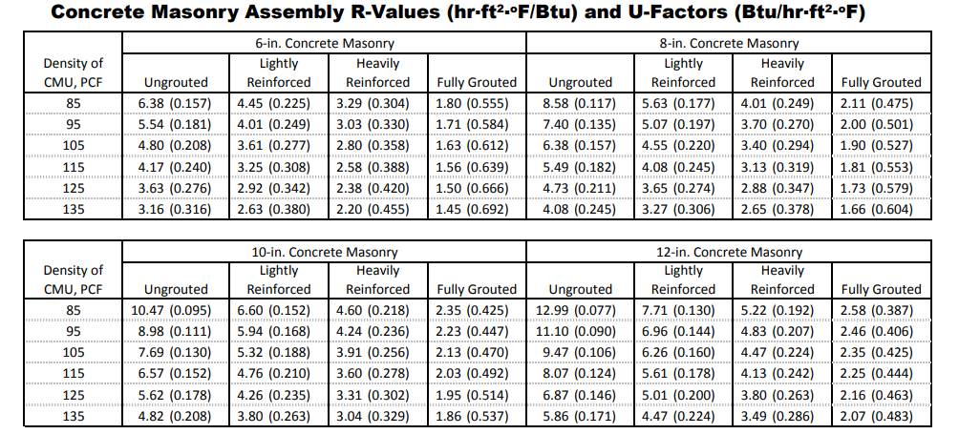
Chart 1: Assembly 1-1
Source: Thermal Catalog of Concrete Masonry Assemblies: Second Addition

Looking at an alternative wall configuration and assuming that the masonry wall can be insulated on the interior face with insulation board, 1-1/2 in. metal furring and 1/2 in. gypsum wallboard, this analysis can be repeated. The figure below shows this system (Assembly 1-4 I -source: Thermal Catalog of Concrete Masonry Assemblies: Second Edition).
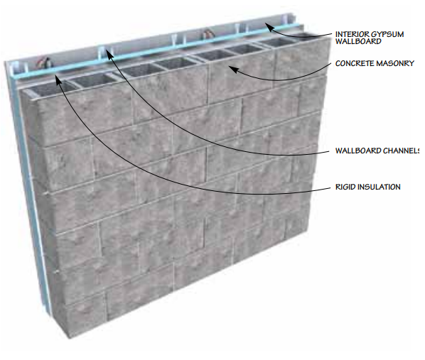
Assembly 1-4
Assembly 1-4 Details
The following details of Assembly 1-1 is an excerpt from the Thermal Catalog of Concrete Masonry Assemblies: Second Edition.
Assembly 1-4: Continuous rigid interior insulation 1-1/2 in. metal furring and 1/2 in. gypsum wallboard on interior, exposed exterior masonry:
- Note that R-values for walls with polyisocyanurate insulation include a reflective air space (i.e. polyisocyanurate is foil-faced and foil-faced side faces the air space).
- Interior furring allows for electrical roughing.
- Reinforcement and grouting schedule has little effect on assembly R-values.
- Interior insulation reduces the benefits of thermal mass.
- “Lightly reinforced” = grout 8 ft o.c. both vertically and horizontally (or vertical reinforcement only at 48 in. o.c.). “Heavily reinforced” = grout 32 in o.c. vertically and 48 in. o.c. horizontally (or vertical reinforcement only at 24 in. o.c.).”
Examination of the NCMA.org Thermal Catalogue shows that as little as ¾ “ Poly Extruded Polystyrene insulation is require to produce U factors well below the maximum allowed by the code.
For wall/unit Configuration 1, the density = 125 lb/ft³. Using the table (shown below) from the Thermal Catalogue, for Extruded Polystyrene, 3/4 inch AND 125 pcf to the column: 8-in. Concrete Masonry, Fully Grouted. The R-value and U-factor in the row and column intersection is “6.58 (0.152)”. The U-factor = 0.152 well below the maximum U-factor found in the California Energy Code = 0.440 therefore the design is acceptable. Assembly 1-4 Table is shown below.
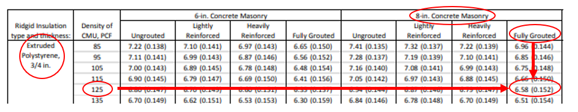

The following table summarizes the Code requirements and U-factors for the five wall/unit configurations for the interior insulation configuration (Assembly 1-4) . Note that other configurations can be used and the user is encouraged to explore other configurations that may be more cost effective for their needs.
Wall/Unit Configuration | 1 | 2 | 3 | 4 | 5
The following Prescriptive values were found in Table 140.3-B in the 2019 California Energy Code
CLIMATE ZONE | 8 | 8 | 8 | 8 | 8
WALL TYPE | Mass  light | Mass  light | Mass  light | Mass  light | Mass  light
WALL MAX  U-FACTOR | 0.440 | 0.440 | 0.440 | 0.440 | 0.440
ROOF TYPE | Low  sloped | Low  sloped | Low  sloped | Low  sloped | Low  sloped
ROOF SOLAR REFLECTANCE | 0.63 | 0.63 | 0.63 | 0.63 | 0.63
ROOF THERMAL EMITTANCE | 0.75 | 0.75 | 0.75 | 0.75 | 0.75
FENESTRATION REQUIREMENT | 40% total gross area or 6 times perimeter | 40% total gross area or 6 times perimeter | 40% total gross area or 6 times perimeter | 40% total gross area or 6 times perimeter | 40% total gross area or 6 times perimeter
The following values were found from the Thermal Catalog
of Concrete Masonry Assemblies: Second Edition
WEB ASSEMBLY | 3-web | 3-web | 3-web | 3-web | 3-web
ASSEMBLY TYPE | Assembly  1-4 | Assembly  1-4 | Assembly  1-4 | Assembly  1-4 | Assembly  1-4
INSULATION | Extruded Polystyrene,  3/4 in | Extruded Polystyrene,  3/4 in | Extruded Polystyrene,  3/4 in | Extruded Polystyrene,  3/4 in | Extruded Polystyrene,  3/4 in
FULLY GROUTED WALL U-FACTOR PROVIDED | 0.152 | 0.150 | 0.144 | 0.144 | 0.144
DESIGN ACCEPTABLE? | YES:  0.152 < 0.440 | YES:  0.150 < 0.440 | YES:  0.144 < 0.440 | YES:  0.144 < 0.440 | YES:  0.144 < 0.440

Example #1 Summary:
Table 3 in the NCMA TEK Note: 06-16A
Configurations were selected from the NCMA TEK Note: 06-16A by first looking at Table 3 with the desired unit length (8-inches) and then looking at the heat capacity that would classify the selection as “Mass Light”. A Mass Light wall is defined in the 2019 California Energy Code as a wall that has a heat capacity of at least 7.0 Btu/h-ft2 and less than 15.0
Table 140.3-B in the California Energy Code
Table 140.3-B in the 2019 California Energy Code is used to identify the Maximum U-factors allowable for design, the Roof Solar Reflectance and Thermal Emittance, and Fenestration Requirements. Values in Table 140.3-B are determined based on the Climate Zone the design will reside in. In Example #1, Climate Zone 8 was chosen as it one of the most populous areas and is used in design frequently.
Thermal Catalog of Concrete Masonry Assemblies: Second Edition
The design called for an 8-inch mass light, fully grouted CMU wall. After obtaining the density and maximum U-factor from TEK Note: 06-16A and the California Energy Code, the assembly of the wall is then selected and evaluated. The Thermal Catalog of Concrete Masonry Assemblies: Second Edition gives a variety of standard assemblies with U-factors allowable for design. The U-factors found in this table are compared to the maximum U-factor found in the California Energy Code. If the U-factor in the Thermal Catalog is less than the U-factor in the California Energy Code, the design is acceptable.

EXAMPLE #2: The following table shows an acceptable design for a Mass Heavy 8-inch fully grouted CMU wall for Climate Zone 8. Mass heavy walls are defined in the 2019 California Energy Code as a wall that has a heat capacity greater than 15.0 Btu/h-ft². Table 3 from the NCMA TEK NOTE: 06-16A gives heat capacities for an 8-inch CMU wall greater than 15.0 Btu/h-ft2 therefore classifying the wall as Mass Heavy. While there are more than one configuration that can be classified as Mass Heavy, just one was used in this example to show the difference in design between a mass light wall and a mass heavy wall in the same climate zone.
An 8-inch fully grouted wall configuration of any density would be classified as a mass heavy wall because the heat capacity is greater than 15.0 Btu/ft²-F (HC = 15.2 Btu/ft²-F)
Looking at a fully grouted wall, the table from the Thermal catalogue for Assembly 1-1 can used (even though there is no insulation in the wall as it is fully grouted). As can be seen in the table any density of units of a fully grouted 8 inch masonry wall have U-factors less than the maximum U-factor value of 0.690 allowed by the code.
Chart 1: Assembly 1-1
Source: Thermal Catalog of Concrete Masonry Assemblies: Second Addition

EXAMPLE #3: The following table shows five acceptable designs for a Mass Heavy 12-inch fully grouted CMU wall for Climate Zone 16 and one for an 8 inch Fully grouted CMU wall. Mass heavy walls are defined in the 2019 California Energy Code as a wall that has a heat capacity greater than 15.0 Btu/h-ft2. Table 5 from the NCMA TEK NOTE: 06-16A gives heat capacities for a 12-inch CMU wall greater than 15.0 Btu/h-ft2 therefore classifies the wall as Mass Heavy. While there are more than five configurations that can be classified as Mass Heavy, only five 12 inch and one 8 inch wall configurations are presented in this example. Note a fully grouted 8 inch CMU wall will be classified as a Mass heavy wall at any density.
Mass Heavy Wall Configurations found from Table 5
 | Unit | Vertical Grout Spacing | Mortar  Bedding | Density | Heat Capacity
Wall Configuration 1 | Hollow | 8 inches | Full | 85 lb/ft³ | 23.9 Btu/ft²-F
Wall Configuration 2 | Hollow | 16 inches | Face shell | 85 lb/ft³ | 15.3 Btu/ft²-F
Wall Configuration 3 | Hollow | 16 inches | Face shell | 95 lb/ft³ | 16.0 Btu/ft²-F
Wall Configuration 4 | Hollow | 16 inches | Face shell | 105 lb/ft³ | 16.7 Btu/ft²-F
Wall Configuration 5 | Hollow | 24 inches | Face shell | 125 lb/ft³ | 15.3 Btu/ft²-F

Based on the tables in the Thermal Catalog of Concrete Masonry Assemblies: Second Edition. Assembly 1-4 (interior insulation) must be used for both the 12 inch and 8 inch wall configuration. From the tables presented in Example 1, the 8 inch wall will produce a U-factor of 0.144 to 0.154, for CMU densities from 85 to 135 pcf and are below the maximum limit of 0.160 allowed by the Code.
The table that followed summarizes the five 12 block configurations that will meet the code prescriptive provisions.

Example #3 Table: Assembly 1-4 Wall Configuration
*Assembly 1-1 will not meet prescriptive code requirements for 12-inch fully grouted, mass heavy walls.
CONFIGURATION | 1 |  | 2 | 3 | 4 | 5
The following values were found from Table 140.3-B in the California Energy Code
CLIMATE ZONE |  | 16 | 16 | 16 | 16 | 16
WALL TYPE |  | Mass  Heavy | Mass  Heavy | Mass  Heavy | Mass  Heavy | Mass  Heavy
WALL MAX  U-FACTOR |  | 0.160 | 0.160 | 0.160 | 0.160 | 0.160
ROOF TYPE |  | Low  sloped | Low  sloped | Low  sloped | Low  sloped | Low  sloped
ROOF SOLAR REFLECTANCE |  | 0.63 | 0.63 | 0.63 | 0.63 | 0.63
ROOF THERMAL EMITTANCE |  | 0.75 | 0.75 | 0.75 | 0.75 | 0.75
FENESTRATION REQUIREMENT |  | 40% total gross area or 6 times perimeter | 40% total gross area or 6 times perimeter | 40% total gross area or 6 times perimeter | 40% total gross area or 6 times perimeter | 40% total gross area or 6 times perimeter
The following values were found from the Thermal Catalog
of Concrete Masonry Assemblies: Second Edition
WEB ASSEMBLY |  | 3-web | 3-web | 3-web | 3-web | 3-web
ASSEMBLY TYPE |  | Assembly  1-4 | Assembly  1-4 | Assembly  1-4 | Assembly  1-4 | Assembly  1-4
INSULATION |  | Extruded Polystyrene,  3/4 in | Extruded Polystyrene,  3/4 in | Extruded Polystyrene,  3/4 in | Extruded Polystyrene,  3/4 in | Extruded Polystyrene,  3/4 in
FULLY GROUTED WALL U-FACTOR PROVIDED |  | 0.135 | 0.135 | 0.137 | 0.139 | 0.143
DESIGN ACCEPTABLE? |  | YES:  0.135 < 0.160 | YES:  0.135 < 0.160 | YES:  0.137 < 0.160 | YES:  0.139 < 0.160 | YES:  0.143 < 0.160

