ANALYSIS OF R-VALUES AND U-FACTORS FROM EXAMPLES
1a. Determine the percent difference between the U-factors of the 2-web and 3-web assembly.
From the previous examples of the 2-web and 3-web assembly, the U-factors were found to be 0.54 and 0.53.
$$Difference= 0.537-0.526=0.011$$
$$Percent Change= \frac{0.011}{0.537}x 100=2.05\%$$
There is only a 2.05% difference between the U-factor for a 2-web and a 3-web.
1b. Determine the percent difference between the R-values of a 2-web fully grouted assembly and a 2-web hollow (ungrouted) assembly.
From the NCMA Thermal Catalog we can directly pull the R- values for a 2-web assembly, both fully grouted and hollow. For this example, assume the density is equal to 105 pcf and an 8-in CMU. 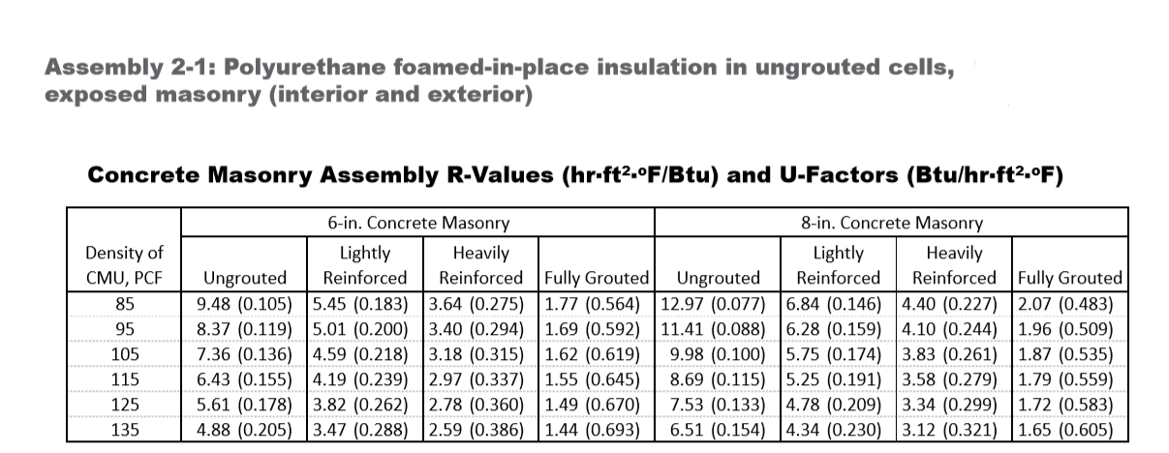
The Ungrouted R-value is equal to 9.98 and the Fully Grouted R-value is equal to 1.87.
$$Difference= 9.98-1.87=8.11$$
$$Percent Change= \frac{8.11}{9.98}x 100=81.3\%$$
There is an 81.3% difference between a 2-web ungrouted assembly and a fully grouted assembly.
2. Compare the calculated R-value from the example to the R-value listed in the corresponding Assembly Tables found in the NCMA Thermal Catalog. Do this for the Assembly 1-1 (3-web) and Assembly 1-8.
ASSEMBLY 2-1 (2-WEB)
Assembly 2-1 (2-web) calculated R-value (8” CMU, density 105 pcf): 1.86
Assembly 2-1: Polyurethane foamed-in-place insulation in ungrouted cells, exposed masonry (interior and exterior), Source: NCMA Thermal Catalog: 1.87
The R-value of 1.86 calculated in the example is nearly the same as the R-value in the Table for a Fully Grouted 8” CMU equal to 1.87. Differences in rounding during calculation should be acknowledged for the 0.01 difference in values.

ASSEMBLY 1-1 (3-WEB)
Assembly 1-1 (3-web) calculated R-value (8” CMU, density 105 pcf): 1.90
Assembly 1-1: Polyurethane foamed-in-place insulation in ungrouted cells, exposed masonry (interior and exterior), Source: NCMA Thermal Catalog: 1.90
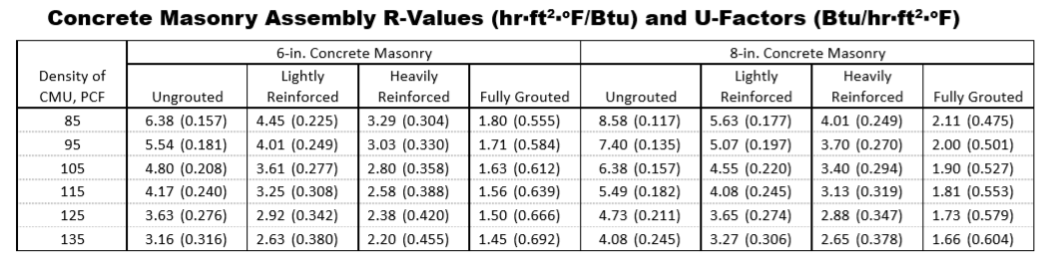
The R-value of 1.90 calculated in the example is the same value as the R-value in the Table for a Fully Grouted 8” CMU equal to 1.90.
ASSEMBLY 1-8
Assembly 1-8 calculated R-value (8” CMU, density 105 pcf): 14.39
Assembly 1-8: Continuous exterior insulation and finish system, exposed interior masonry 2.5” extruded polystyrene insulation, Source: NCMA Thermal Catalog: 14.60
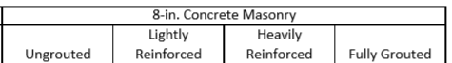
The closest value to the calculated R-value of 14.39 that we find in the Table is the Fully Grouted 14.60. Difference in the R-values is due to the assumption in the example that there is no air between the insulation. If air were accounted for in the example, these values would be equal. It is important to understand how different assumptions can change the total R-value.
3. Factors that can impact the R-value calculation:
There are certain factors that can impact the R-value calculation that must be considered:
- Density of the concrete masonry unit
- Size of the concrete masonry unit
- Location of the amount of the grouted reinforcement in the assembly
- The amount of insulation in the assembly

